5 A dining table has been manufactured from lengths of wood. Figure 4 shows a cross sectional view of two of the table legs.

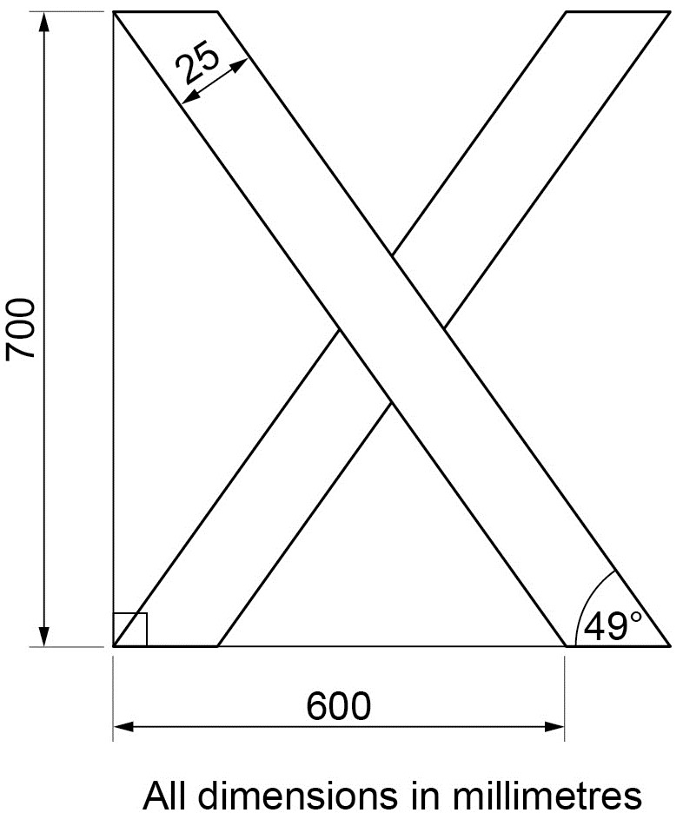

A

B

Figure 4 Cross sectional view of two of the table legs

Describe how the dining table in Figure 4 could be manufactured using manual woodworking techniques.

In your answer, you should:

- Determine the length AB shown in Figure 4
- Calculate the minimum total length of a single piece of wood required to manufacture the four legs of the table, assuming no wastage from the cutting processes. Ignore blade thickness for the purpose of the calculation.
- Refer to the tools and processes used in the different stages of manufacture.

[14 marks]

