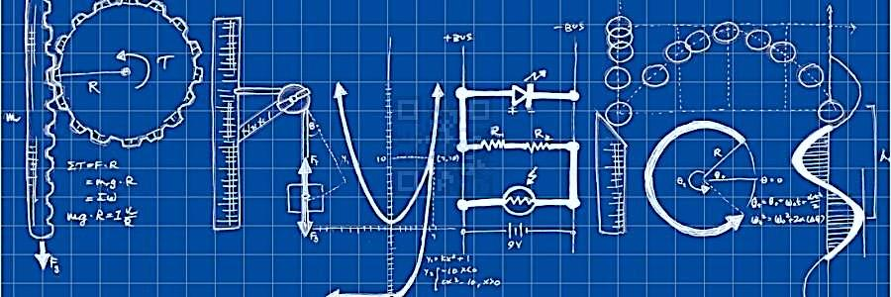

A Level Physics at Verulam

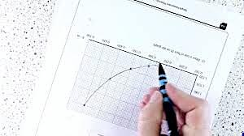

Transition Booklet from GCSE Physics to A Level Physics

Introduction

This booklet will assist you in getting better prepared to study A Level Physics at Verulam. You must work through the booklet and self-assess to identify the topics/areas for improvement. Write a brief comment on your progress in the comments box as you complete each topic.This help will inform you with what you must revise prior to beginning the A Level Physics course.

A Level Physics | Contents
Skills

Topic | Title | Completed  (date) | Comments.  Do you need more practice?  Are you confident with this area?  What areas of weakness have you identified?
1 | Prefixes and units
2 | Significant Figures
3 | Converting Length, Area and Volume
4 | Rearranging Equations
5 | Variables
6 | Constructing Tables
7 | Drawing Lines of Best Fit
8 | Constructing Graphs
9 | Calculating Gradients – Straight Lines
10 | Calculating Gradients – Curved Lines
11 | Calculating Areas – Straight Line Graphs
12 | Calculating Areas – Curved Line Graphs
13 | Interpreting Graphs
14 | Accuracy vs Precision
15 | Identifying Errors
16 | Improving Experiments – Accuracy, Precision and Reliability
17 | Describing Experiments
18 | Appendix 1 Solutions. Appendix 2 It’s all Greek
A Level Physics | 1. Prefixes and units
Skills

In Physics we have to deal with quantities from the very large to the very small. A prefix is something that goes in front of a unit and acts as a multiplier. This sheet will give you practice at converting figures between prefixes.

Symbol | Name | What it means |  | How to convert
P | peta | 10¹⁵ | 1000000000000000 |  | ↓ x1000
T | tera | 10¹² | 1000000000000 | ↑ ÷ 1000 | ↓ x1000
G | giga | 10⁹ | 1000000000 | ↑ ÷ 1000 | ↓ x1000
M | mega | 10⁶ | 1000000 | ↑ ÷ 1000 | ↓ x1000
k | kilo | 10³ | 1000 | ↑ ÷ 1000 | ↓ x1000
 |  |  | 1 | ↑ ÷ 1000 | ↓ x1000
m | milli | 10⁻³ | 0.001 | ↑ ÷ 1000 | ↓ x1000
μ | micro | 10⁻⁶ | 0.000001 | ↑ ÷ 1000 | ↓ x1000
n | nano | 10⁻⁹ | 0.000000001 | ↑ ÷ 1000 | ↓ x1000
p | pico | 10⁻¹² | 0.000000000001 | ↑ ÷ 1000 | ↓ x1000
f | femto | 10⁻¹⁵ | 0.000000000000001 | ↑ ÷ 1000

Convert the figures into the units required. Convert these figures to suitable prefixed units.
6 km | = | 6 x 10³ m |  | 640 GV | = | 640 x 10⁹ V
54 MN | = | N |  |  | = | 0.5 x 10⁻⁶ A
0.086 µV | = | V |  |  | = | 93.09 x 10⁹ m
753 GPa | = | Pa |  | kN | = | 32 x 10⁵ N
23.87 mm/s | = | m/s |  | nm | = | 0.024 x 10⁻⁷ m

Convert the figures into the prefixes required.
s | ms | μs | ns | ps
0.00045 | 0.45 | 450 | 450 000  or 450 x10³ | 450 x 10⁶
0.000000789
0.000 000 000 64

mm | m | km | µm | Mm
1287360
295

The equation for wave speed is:
$$wave speed=frequency ×wavelength$$
$$(m/s) \left(Hz\right) (m)$$
Whenever this equation is used, the quantities must be in the units stated above. At GCSE we accepted m/s but at AS/A Level we use the index notation. m/s becomes m s⁻¹ and m/s² becomes m s⁻².
By convention we should also leave one space between values and units. 10m should be 10 m.
We also leave a space between different units but no space between a prefix and units.
This is to remove ambiguity when reading values.
Example ms⁻¹ means 1/millisecond because the ms means millisecond, 10⁻³ s
but m s⁻¹ means metre per second the SI unit for speed.
or mms⁻¹ could mean mm s⁻¹ compared with m ms⁻¹
millimeters per second compared with meters per millisecond - quite a difference!!!
Calculate the following quantities using the above equation, giving answers in the required units.
- Calculate the speed in m s⁻¹ of a wave with a frequency of 75 THz and a wavelength 4.0 µm.
v = f λ = 75 x 10¹² x 4.0 x 10⁻⁶ = 3.0 x 10⁸ m s⁻¹ ( 300 Mm s⁻¹)
- Calculate the speed of a wave in m s⁻¹ which has a wavelength of 5.6 mm and frequency of 0.25 MHz.

- Calculate the wavelength in metres of a wave travelling at 0.33 km s⁻¹ with a frequency of 3.0 GHz.

- Calculate the frequency in Hz of a wave travelling at 300 x 10³ km s⁻¹ with a wavelength of 0.050 mm.

- Calculate the frequency in GHz of a wave travelling at 300 Mm s⁻¹ that has a wavelength of 6.0 cm.

A Level Physics | 2. Significant Figures
Skills

1. All non-zero numbers ARE significant. The number 33.2 has THREE significant figures because all of the digits present are non-zero.
2. Zeros between two non-zero digits ARE significant. 2051 has FOUR significant figures. The zero is between 2 and 5
3. Leading zeros are NOT significant. They're nothing more than "place holders." The number 0.54 has only TWO significant figures. 0.0032 also has TWO significant figures. All of the zeros are leading.
4. Trailing zeros when a decimal is shown ARE significant. There are FOUR significant figures in 92.00 and there are FOUR significant figures in 230.0.
5. Trailing zeros in a whole number with no decimal shown are NOT significant. Writing just "540" indicates that the zero is NOT significant, and there are only TWO significant figures in this value.
(THIS CAN CAUSE PROBLEMS!!! WE SHOULD USE POINT 8 FOR CLARITY, BUT OFTEN DON’T - 2/3 significant figures is accepted in IAL final answers - eg 500/260 = 1.9 to 2 sf. Better 5.0 x 10² / 2.6 x 10² = 1.9)
8. For a number in scientific notation: N x 10^{x}, all digits comprising N ARE significant by the first 5 rules; "10" and "x" are NOT significant. 5.02 x 10⁴ has THREE significant figures.
For each value state how many significant figures it is stated to.
Value | Sig Figs | Value | Sig Figs | Value | Sig Figs | Value | Sig Figs
2 |  | 1066 |  | 1800.45 |  | 0.070
2.0 |  | 82.42 |  | 2.483 x 10⁴ |  | 69324.8
500 |  | 750000 |  | 0.0006 |  | 0.0063
0.136 |  | 310 |  | 5906.4291 |  | 9.81 x 10⁴
0.0300 |  | 3.10 x 10⁴ |  | 200000 |  | 40000.00
54.1 |  | 3.1 x 10² |  | 12.711 |  | 0.0004 x 10⁴

When adding or subtracting numbers
Round the final answer to the least precise number of decimal places in the original values.
Eg. 0.88 + 10.2 – 5.776 (= 5.304) = 5.3 (to 1d.p. , since 10.2 only contains 1 decimal place)
(Khan Academy- Addition/ subtraction with sig fig excellent video- make sure you watch .)
Add the values below then write the answer to the appropriate number of significant figures

Value 1 | Value 2 | Value 3 | Total Value | Total to correct sig figs
51.4 | 1.67 | 3.23
7146 | –32.54 | 12.8
20.8 | 18.72 | 0.851
1.4693 | 10.18 | –1.062
9.07 | 0.56 | 3.14
739762 | 26017 | 2.058
8.15 | 0.002 | 106
152 | 0.8 | 0.55

When multiplying or dividing numbers
Round the final answer to the least number of significant figures found in the initial values.
E.g. 4.02 x 3.1 ⎟ 0.114 = (109.315…) = 110 (to 2s.f. as 3.1 only has 2 significant figures.
Multiply the values below then write the answer to the appropriate number of significant figures
Value 1 | Value 2 | Total Value | Total to correct sig figs
0.91 | 1.23
8.764 | 7.63
2.6 | 31.7
937 | 40.01
0.722 | 634.23

Divide value 1 by value 2 then write the answer to the appropriate number of significant figures
Value 1 | Value 2 | Total Value | Total to correct sig figs
5.3 | 748
3781 | 6.50
91 x 10² | 180
5.56 | 22 x 10⁻³
3.142 | 8.314

When calculating a mean

- Remove any obvious anomalies (circle these in the table)
- Calculate the mean with the remaining values, and record this to the least number of decimal places in the included values
E.g. Average 8.0, 10.00 and 145.60:
1) Remove 145.60
2) The average of 8.0 and 10.00 is 9.0 (to 1 d.p.)

Calculate the mean of the values below then write the answer to the appropriate number of significant figures
Value 1 | Value 2 | Value 3 | Mean Value | Mean to correct sig figs
1 | 1 | 2
435 | 299 | 437
5.00 | 6.0 | 29.50
5.038 | 4.925 | 4.900
720.00 | 728.0 | 725
0.00040 | 0.00039 | 0.000380
31 | 30.314 | 29.7

A Level Physics | 3. Converting length, area and volume
Skills

Whenever substituting quantities into an equation, you must always do this in SI units – such as time in seconds, mass in kilograms, distance in metres…
If the question doesn’t give you the quantity in the correct units, you should always convert the units first, rather than at the end. Sometimes the question may give you an area in mm² or a volume in cm³, and you will need to convert these into m² and m³ respectively before using an equation.
To do this, you first need to know your length conversions:
1m = 100 cm = 1000 mm (1 cm = 10 mm)
m 🡪 cm | x 100 | cm 🡪 m | ÷ 100
m 🡪 mm | x 1000 | m 🡪 mm | ÷ 1000

Always think –
“Should my number be getting larger or smaller?” This will make it easier to decide whether to multiply or divide.
Converting Areas
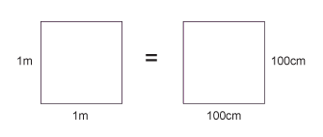
A 1m x 1m square is equivalent to a 100 cm x 100 cm square.
Therefore, 1 m² = 10 000 cm²
Similarly, this is equivalent to a 1000 mm x 1000 mm square;
So, 1 m² = 1 000 000 mm²
m² 🡪 cm² | x 10 000 | cm² 🡪 m² | ÷ 10 000
m² 🡪 mm² | x 1 000 000 | m² 🡪 mm² | ÷ 1 000 000

Converting Volumes
A 1m x 1m x 1m cube is equivalent to a 100 cm x 100 cm x 100 cm cube.
Therefore, 1 m³ = 1 000 000 cm³
Similarly, this is equivalent to a 1000 mm x 1000 mm x 1000 mm cube;
So, 1 m³ = 10⁹ mm³
m³ 🡪 cm³ | x 1 000 000 | cm³ 🡪 m³ | ÷ 1 000 000
m³ 🡪 mm³ | x 10⁹ | m³ 🡪 mm³ | ÷ 10⁹

6 m² | = | cm² |  | 750 mm² | = | m²
0.002 m² | = | mm² |  | 5 x 10⁻⁴ cm³ | = | m³
24 000 cm² | = | m² |  | 8.3 x 10⁻⁶ m³ | = | mm³
46 000 000 mm³ | = | m³ |  | 3.5 x 10² m² | = | cm²
0.56 m³ | = | cm³ |  | 152000 mm² | = | m²

Now use the technique shown on the previous page to work out the following conversions:
31 x 10⁸ m² | = | km²
59 cm² | = | mm²
24 dm³ | = | cm³
4 500 mm² | = | cm²
5 x 10⁻⁴ km³ | = | m³
(Hint: There are 10 cm in 1 dm)

A 2.0 m long solid copper cylinder has a cross-sectional area of 3.0 x10² mm². What is its volume in cm³?

Volume = cm³

For the following, think about whether you should be writing a smaller or a larger number down to help decide whether you multiply or divide.
Eg. To convert 5 m ms⁻¹ into m s⁻¹ – you will travel more metres in 1 second than in 1 millisecond, therefore you should multiply by 1000 to get 5000 m s⁻¹.
5 N cm⁻² | = | N m⁻²
1150 kg m⁻³ | = | g cm⁻³
3.0 m s⁻¹ | = | km h⁻¹
65 kN cm⁻² | = | N mm⁻²
7.86 g cm⁻³ | = | kg m⁻³

A Level Physics | 4. Rearranging Equations
Skills

Rearrange each equation into the subject shown in the middle column.
Equation |  | Rearrange Equation
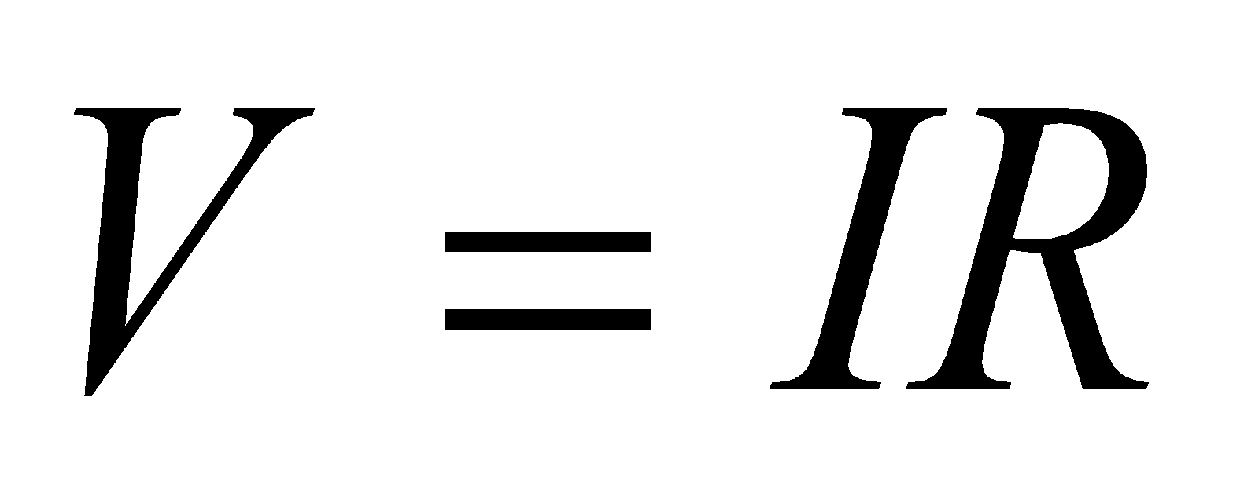 | R
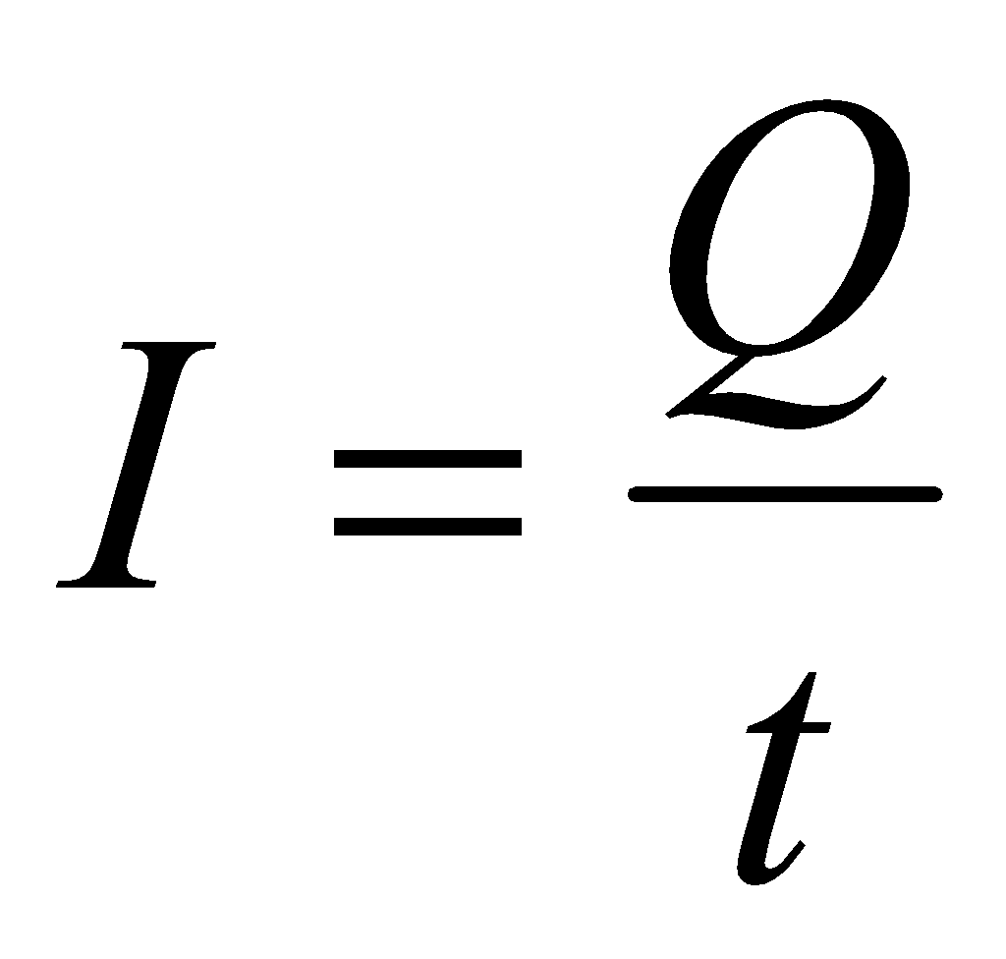 | t
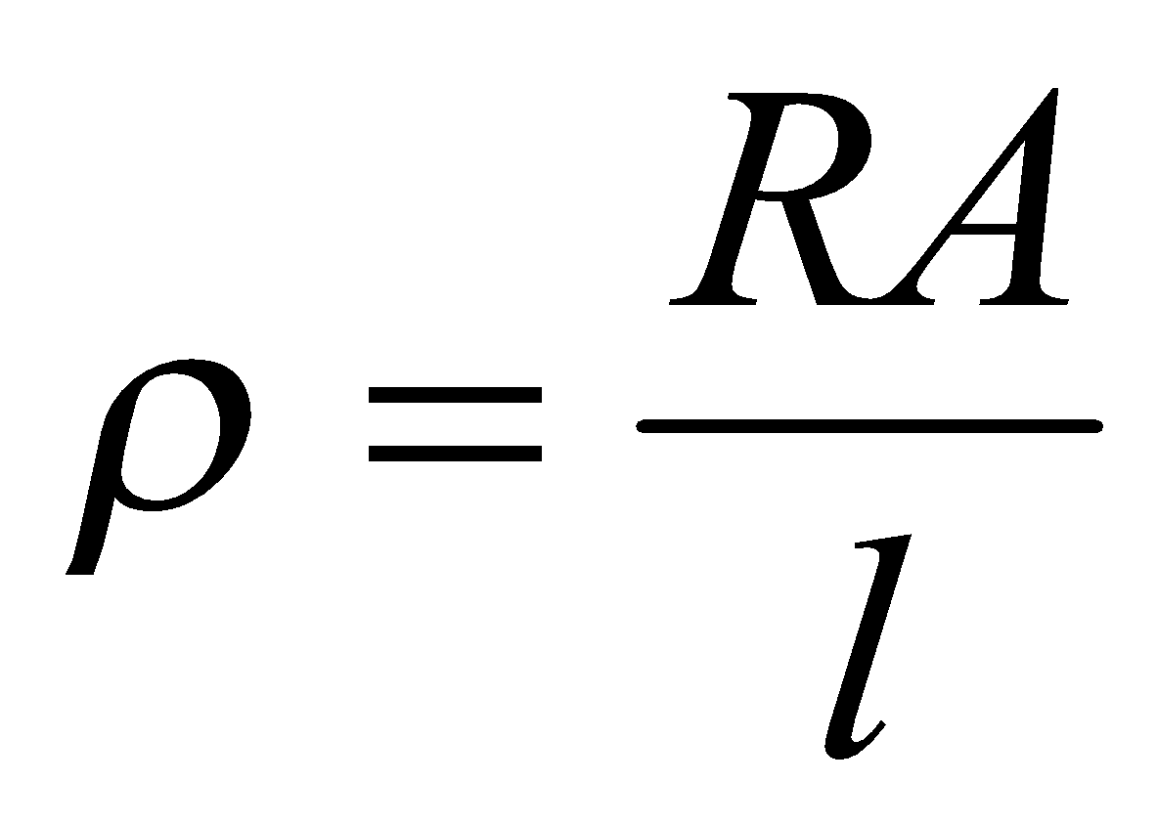 | A
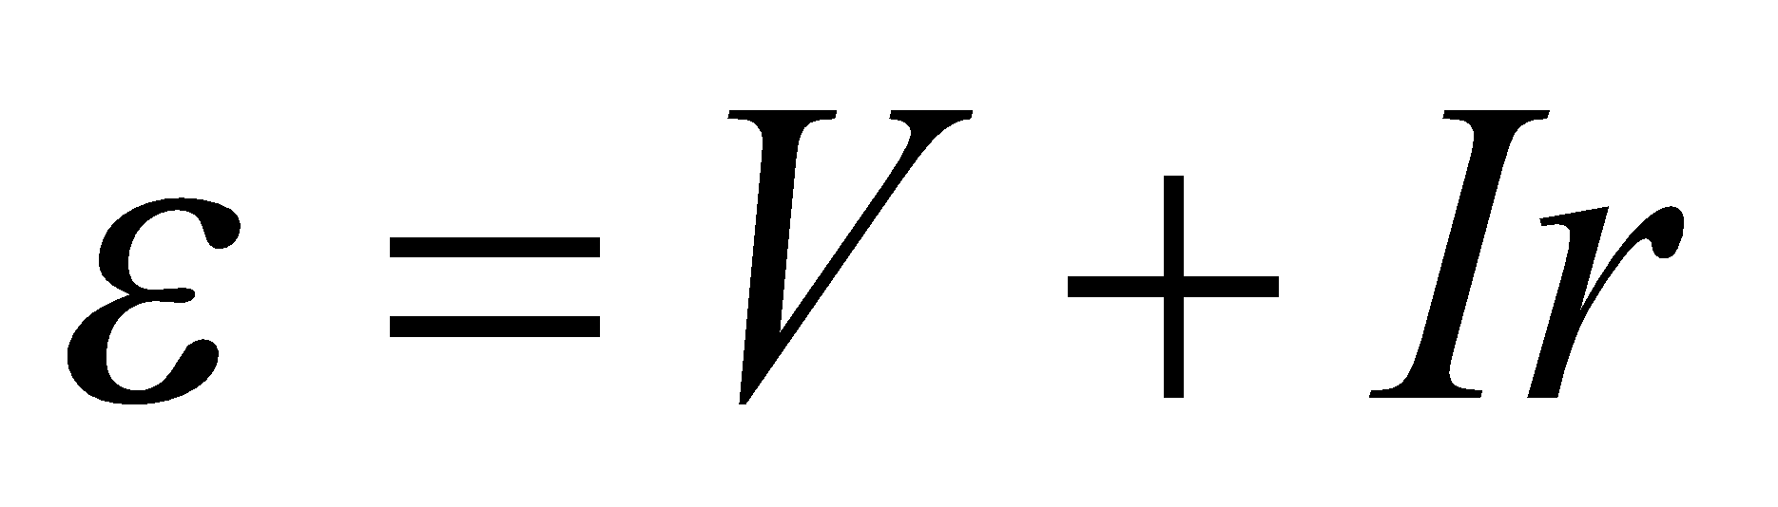 | r
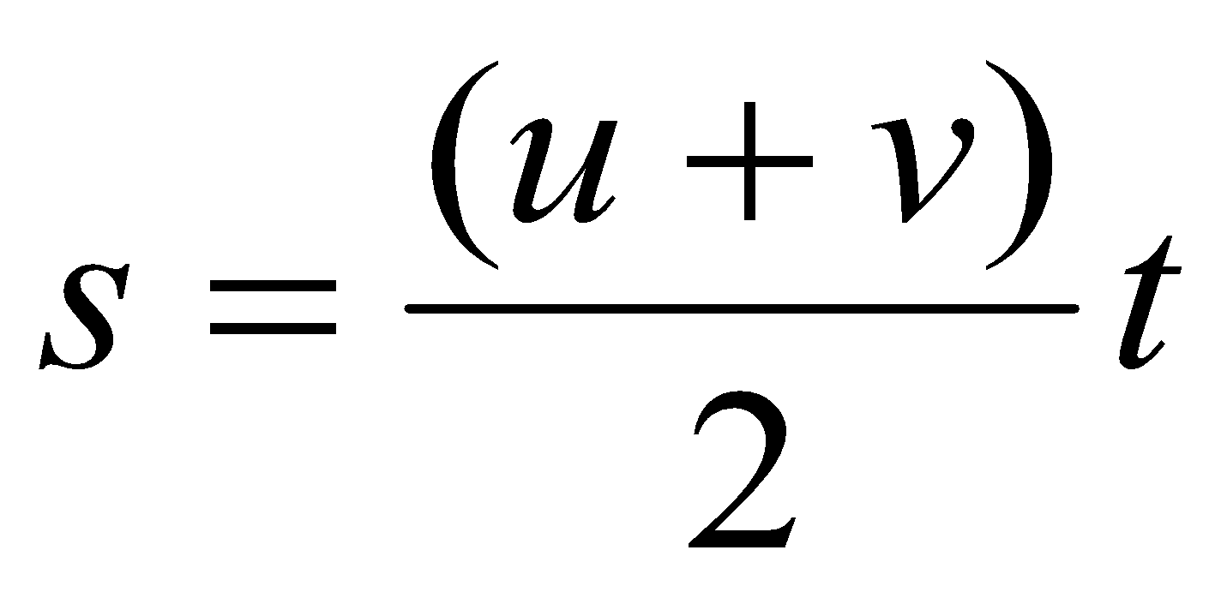 | u

Equation |  | Rearrange Equation
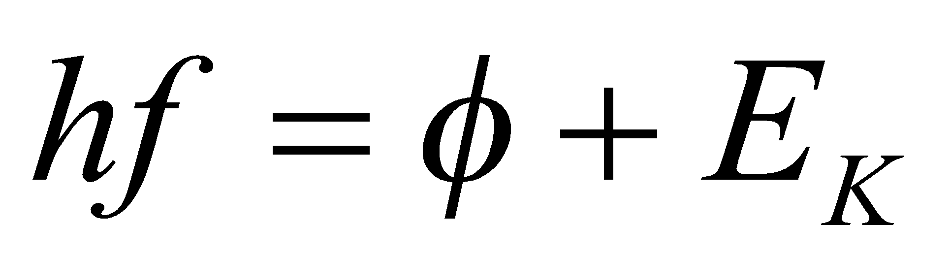 | f
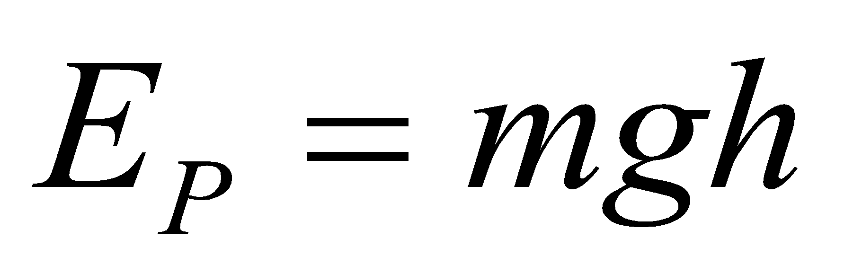 | g
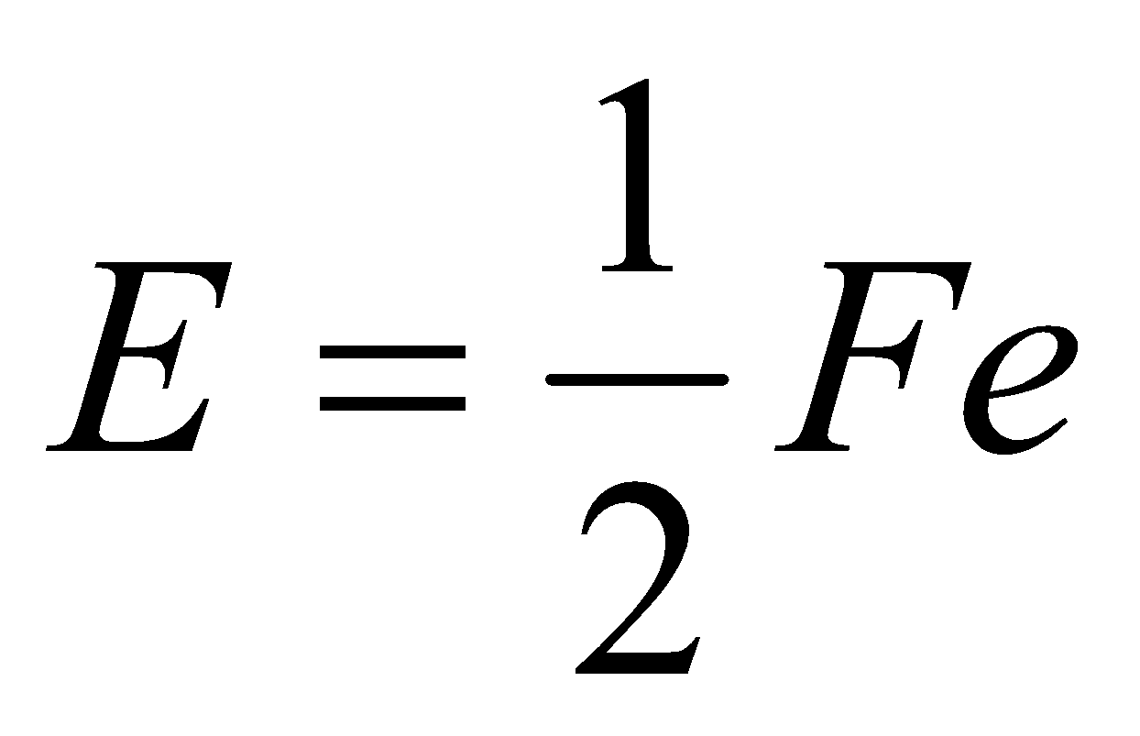 | F
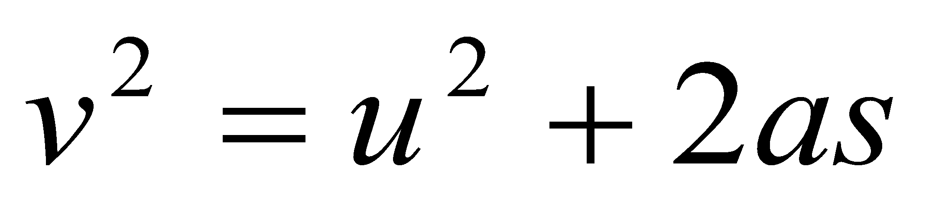 | u
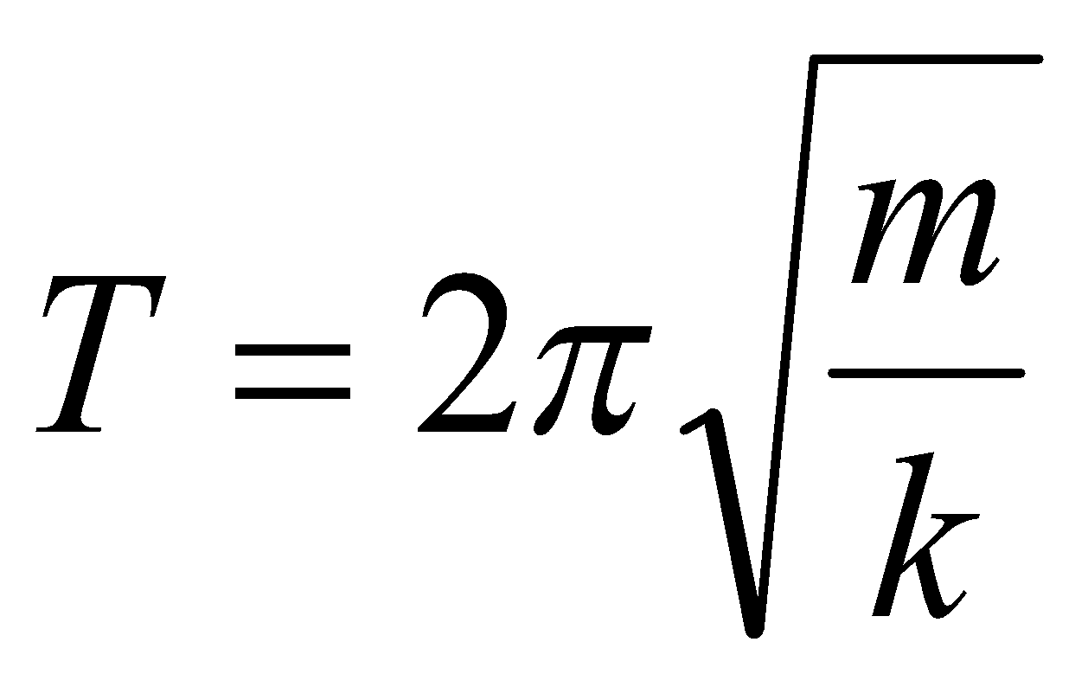 | m

A Level Physics | 5. Variables
Skills
A variable is a quantity that takes place in an experiment. There are three types of variables:
Independent variable – this is the quantity that you change
Dependent variable – this is the quantity that you measure
Control variable – this is a quantity that you keep the same so that it does not affect the results
You can only have one independent variable and one dependent variable, but the more control variables you have the more accurate your results will be.
Further to these, you can also split the independent variable category – this can be continuous or discrete.
A continuous variable can take any numerical value, including decimals. You will construct line graphs for continuous variables.
A discrete variable can only take specific values or labels (eg. integers or categories). You will construct bar charts for discrete variables.

For each case study below, state the independent variable, dependent variable, and any control variables described. Add further control variables, and state what type the independent variable is and what type of graph you will present the results with (if required).

Case study 1 – Measuring the effect of gravity
The aim of this experiment is to find out how fast objects of different masses take to fall from height. To conduct this experiment we used a number of spheres of the same diameter, which had different masses. Each sphere had its mass measured on electronic scales, before being dropped from a marker exactly 2.000 m from the floor. The time the sphere took to drop was timed on a stopwatch, and repeated 3 times for each sphere to gain an average time.

Independent variable:
Dependent variable:
Control variables:

Type of independent variable:
Graph:

Case study 2 – The number of children involved in different after school activities.
The aim of this study is to discover which activities are most popular so the correct resources can be supplied to the correct member of staff. On a certain day after school the number of children were recorded for the different activities they took.
Independent variable:
Dependent variable:
Control variables:

Type of independent variable:
Graph:

Case study 3 – How far does the spring stretch?
The aim of this experiment is to find how far different masses stretch a spring. A spring was hung from a clamp stand, and its length end to end measured. A 10g mass was then added and the length of the spring measured and recorded. This was repeated adding 10g between 0g and 100g.
Independent variable:
Dependent variable:
Control variables:
Type of independent variable:
Graph:

Case study 4 - What is the best design for a turbine?
A wind turbine is connected to a voltmeter and is placed 1.0 m from a desk fan. The potential difference produced for different number of blades attached to the turbine is measured. The aim is to see what design produces the largest potential difference.
Independent variable:
Dependent variable:
Control variables:

Type of independent variable:
Graph:

A Level Physics | 6. Constructing tables
Skills

The left hand column is for your independent variable.
The right hand column is for your dependent variable. You may split this up into further columns if repeats are carried out, and make sure you include an average column. Each sub column must come under the main heading (including the average column).
Place results in the table in order of independent variable, usually starting with the smallest value first.
Ensure each column contains a heading with units in brackets. No units should be placed in the table.
All measured values in one column should be to the same decimal place – don’t forget to add zeros if necessary!
Any averages should be given to the same number of decimal places as the measured values. Remember to remove any anomalies by circling the results and do not include them in calculating your average.
Any calculated values should be given to a suitable number of significant figures/ precision.
At AS/A Level we don’t use brackets to separate the quantity heading from the units but use a / .
Example: mass ( kg) should be written as mass / kg.
speed of car ( m/s) should be written as speed of car / m s⁻¹
Independent Variable Heading  /unit | Dependent Variable Heading  /unit
 | 1 | 2 | 3 | Average

A student forgot his exercise book when doing a practical on electrical resistance for a resistor. Below are his readings in the practical. He measured the current in the circuit three times for five different voltages. He has made many errors.
V : 0.11A, 0.1A, 0.12A
2.0V : 0.21A, 0.18A, 0.24

5V : 0.5, 5.1, 0.48 4.0V : 0.35A, 0.40A, 0.45

3.0V: 0.33A, 0.6
0.30

Construct a suitable table for his results.
A Level Physics | 7. Drawing Lines of Best Fit
Skills

When drawing lines of best fit, draw a smooth straight or curved line that passes through the majority of the points. If you can, try to have an even number of points above and below the line if it can’t go through all points.

When describing the trend, use the phrase….

“As ‘X’ increases, ‘Y’ increases/decreases in a linear/non-linear fashion.”

Substitute the quantities into X and Y, and choose either of the two options to describe the graph.
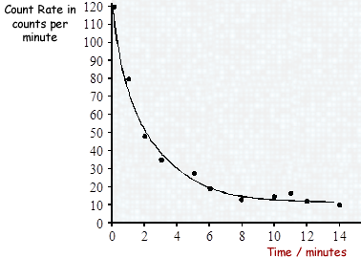
Eg.

As time increases, the count rate decreases in a non-linear fashion.

Draw a line of best fit for each of the graphs and describe the trend shown by each (call the quantities X and Y).

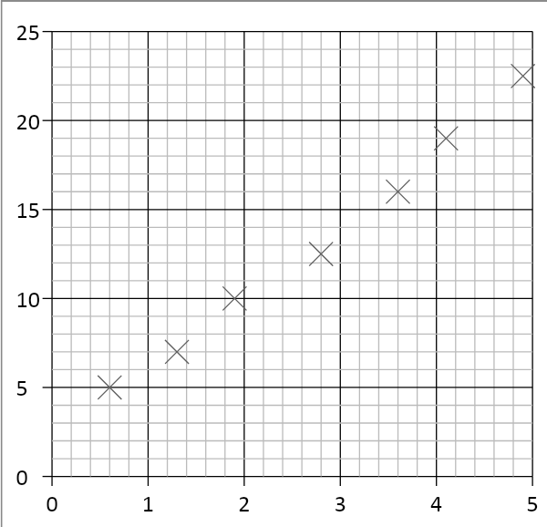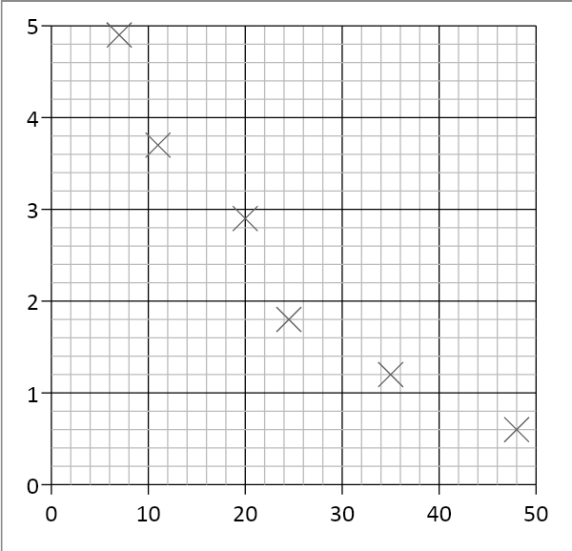

- 2.

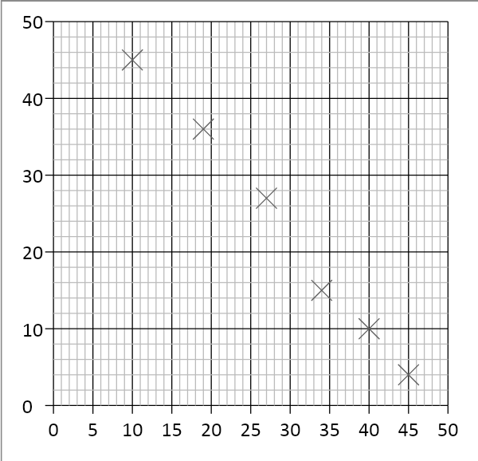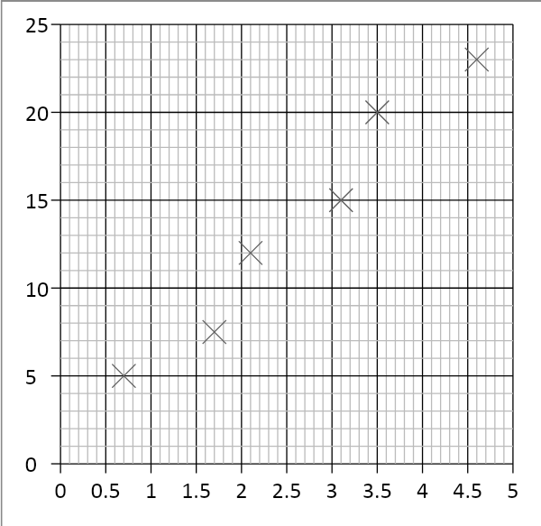

3. 4.

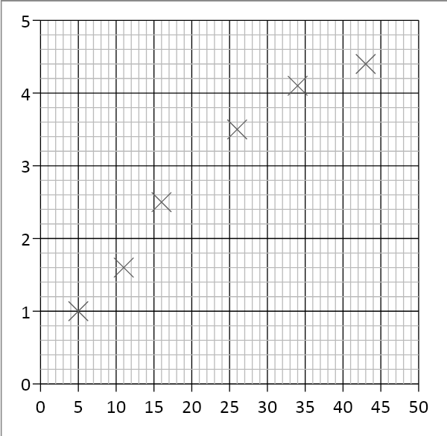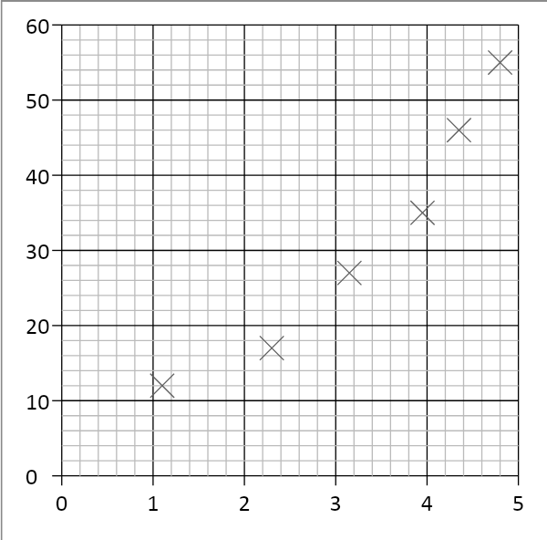

5. 6.

A Level Physics | 8. Constructing Graphs
Skills

When drawing graphs, you will be marked on the following criteria:
- Axes – Your independent variable is on the x axis, and your dependent variable is on the y axis. Both axes need to be labelled.
- Units – Add units to your axes when labelling.
- Scale – Make your scale as large as possible so that your data fills most of the page. You don’t have to start your axes at the origin. Make sure you have a regular scale that goes up in nice numbers – 1, 2, 5, 10 etc…
- Points – mark each point with a cross using a sharp pencil. Don’t use circles or dots as points.
- Line of best fit – draw a smooth line of best fit – straight or curved depending on what pattern your data follows.
An easy way to remember these points is….. S cale
L ine
A xes
P oints
U nits
Plot graphs for the following sets of data, including a line of best fit for each.
Surface area of pendulum / cm² | Time taken for pendulum to stop/ s
5.0 | 170
6.2 | 127
7.4 | 99
8.0 | 86
8.8 | 70
9.9 | 56
Current / A | Voltage / V
0.07 | 1.46
0.14 | 1.44
0.21 | 1.42
0.30 | 1.40
0.41 | 1.38
0.57 | 1.33
0.81 | 1.29
A Level Physics | 9. Calculating Gradients – Straight Lines
Skills
Gradients are a useful tool that show how fast or slow quantities change – eg speed tells us how fast distance is changing, or how quickly energy is being lost over time.

To calculate the gradient, pick any two points on the line as far away as possible and draw a large triangle between them.
The gradient is given by:
$gradient= \frac{diffference in y values}{difference in x values}$
But make sure the you subtract the values in the same order! Remember – if the line slopes up, the gradient should be positive; if the line slopes down, then the gradient should be negative.

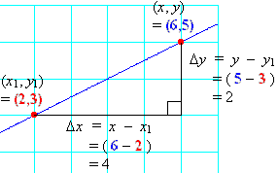
Gradient = $\frac{difference in y}{difference in x}$
= $\frac{2}{4}$
= 0.5

Calculate the gradients of the graphs below
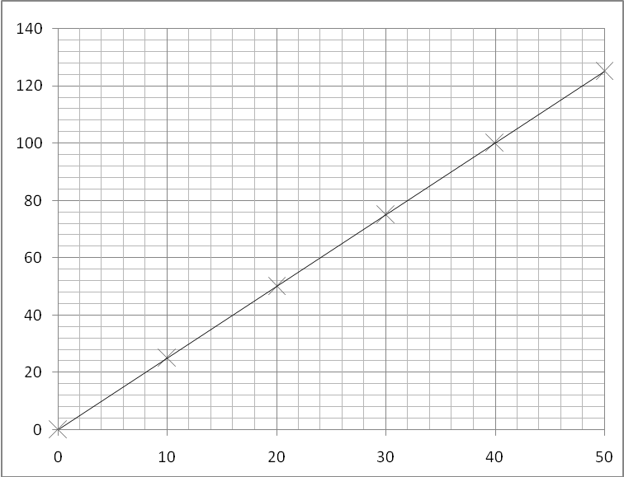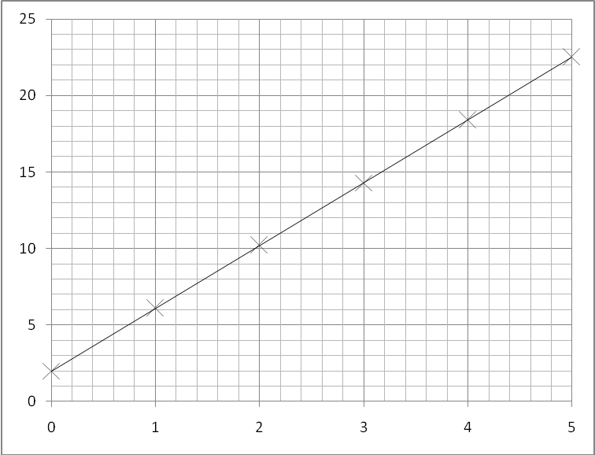
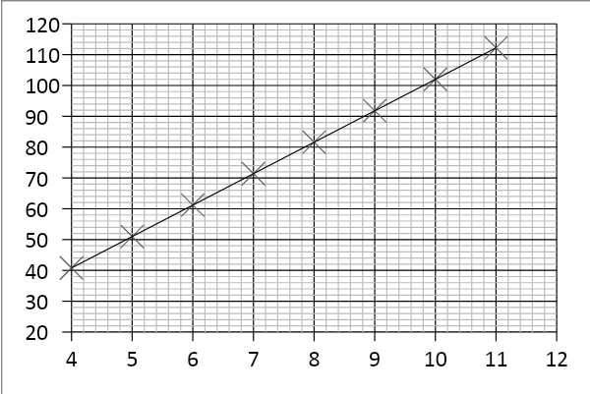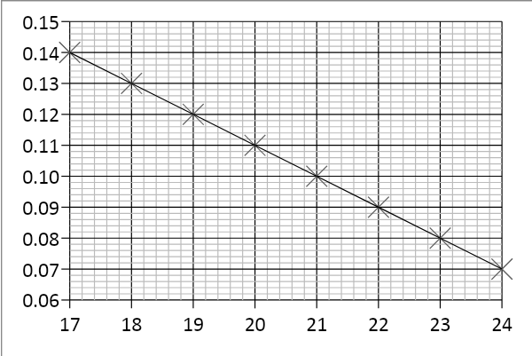
A Level Physics | 10. Calculating Gradients – Curved Lines
Skills

Most graphs in real life are not straight lines, but curves; however it is still useful to know how the quantity changes over time, hence we still need to calculate gradients.

If we want to know the gradient at a particular point, firstly we need to draw a tangent to the curve at that point.
A tangent is a straight line that follows the gradient at the required point. Once we have drawn the straight line tangent, its gradient can be calculated in exactly the same way as the previous page showed.

Tip – make sure your tangents and gradient triangles are as big as possible to be as accurate as you can!

Examples of drawing tangents and calculating the gradient of a tangent:

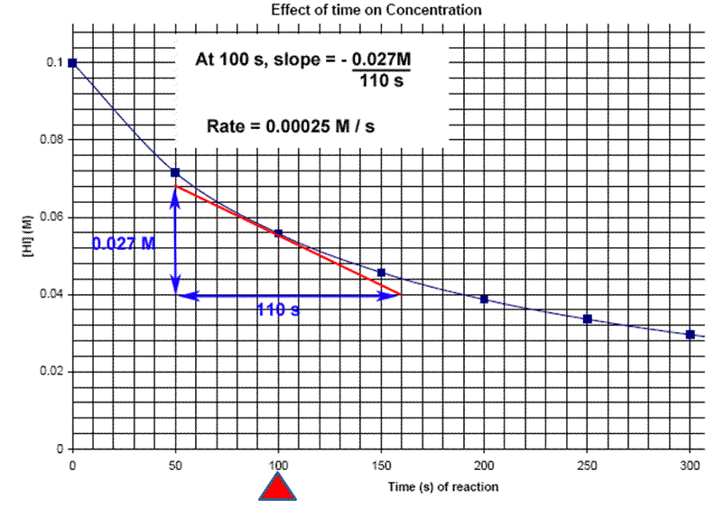
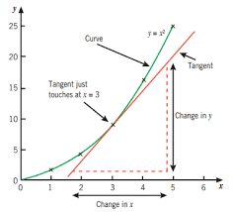

Rate = - 0.00025 M/s

Draw a tangent to the line and calculate its gradient at the following x-axis values:
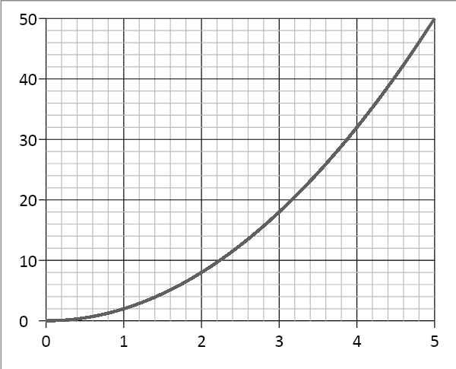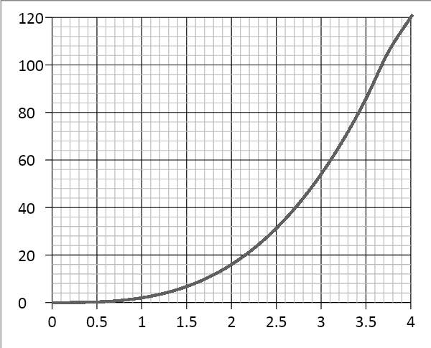
2.0 and 4.0 1.5 and 3.5
( Note - gradients in Physics often have units, this is something we will consider as we progress in the course)

A Level Physics | 11. Calculating Areas – Straight line Graphs
Skills

Often other quantities can be found by multiplying the two quantities represented on a graph together (for example, multiplying velocity and time gives distance travelled). The exact quantity can be found by calculating the area under the graph.
If the graph is made of straight lines, the total area can be found by splitting the graph into segments of rectangles and triangles (or into a trapezium) and adding those areas together.
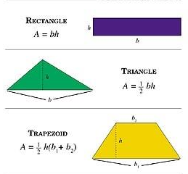

Important – the heights that you use should always be the perpendicular height from the base.

Calculate the distance travelled by determining the area under the graph:
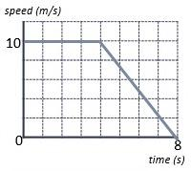

Area A = 10 x 4 = 40 m
Area B = ½ x 4 x 10 = 20 m
A
Total Area = A + B = 40 + 20 = 60 m
B
Or
Area of trapezium = ½ (4 + 8) x 10 = 60 m

Calculate the area of the below graphs and the correct unit for that area.

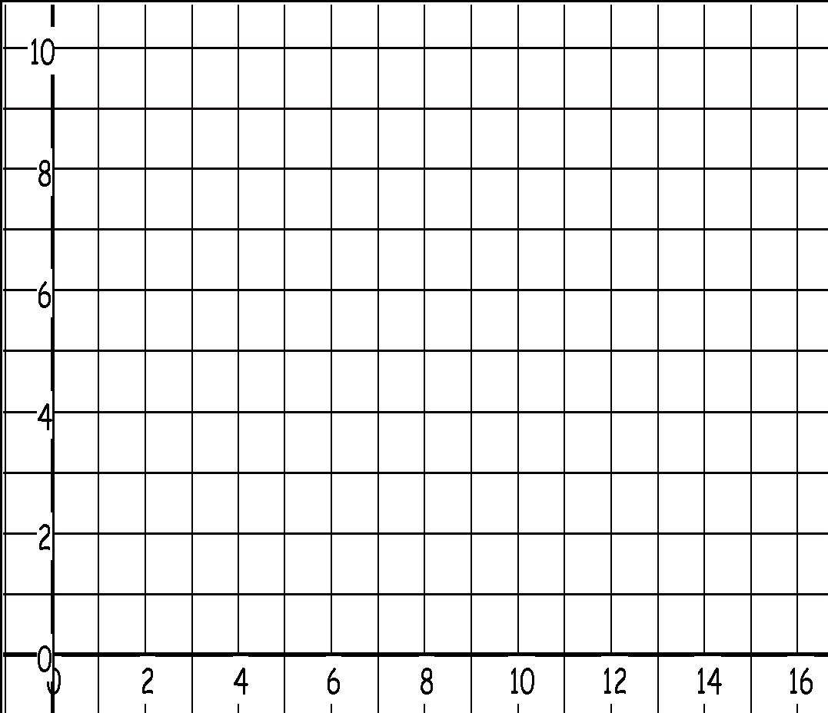

Time/s
Velocity/ m s⁻¹

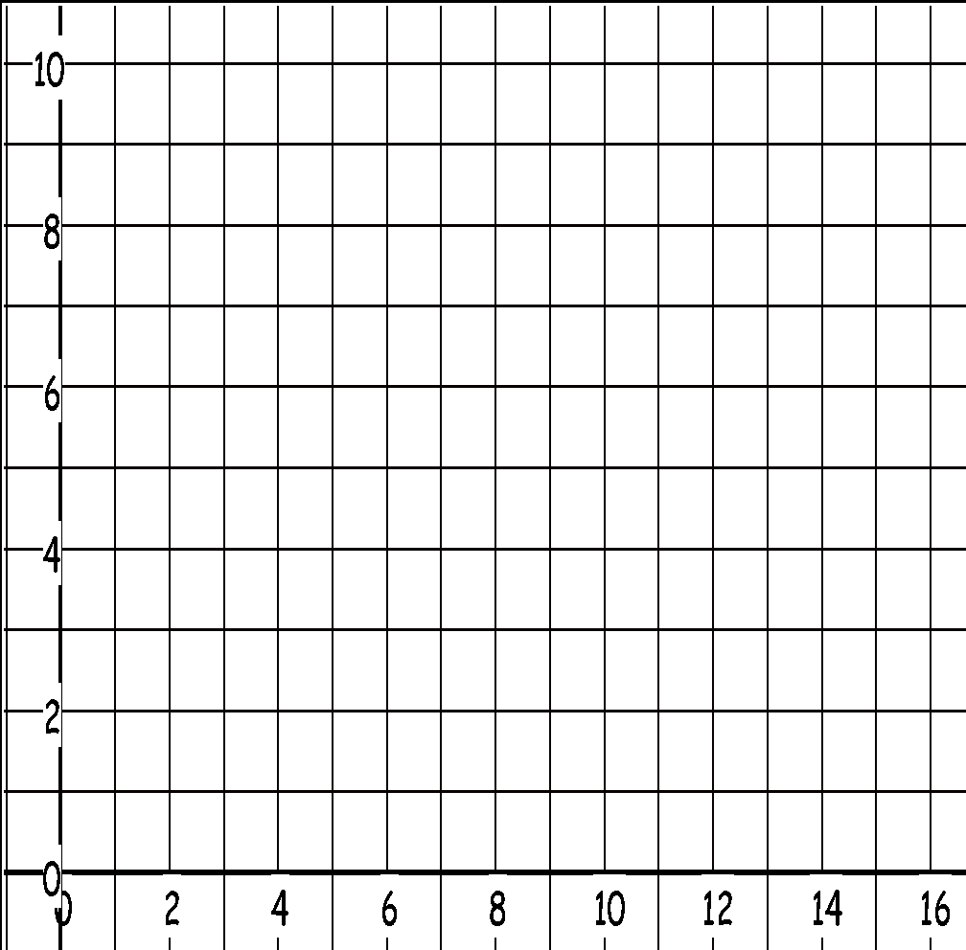

Time / s
Velocity /m s⁻¹

A Level Physics | 12. Calculating Areas – Curved line Graphs
Skills

When graphs have curved lines we use a simple process of counting squares and estimating.
- Calculate the area of 1 small (but the not smallest!) square on the graph
- Count the number of whole squares under the line
- Estimate the whole number of squares that have been segmented by the line.
- Multiply the total number of squares by the area of one square to estimate the area.

Eg. Work out the distance travelled by calculating the area under the graph.
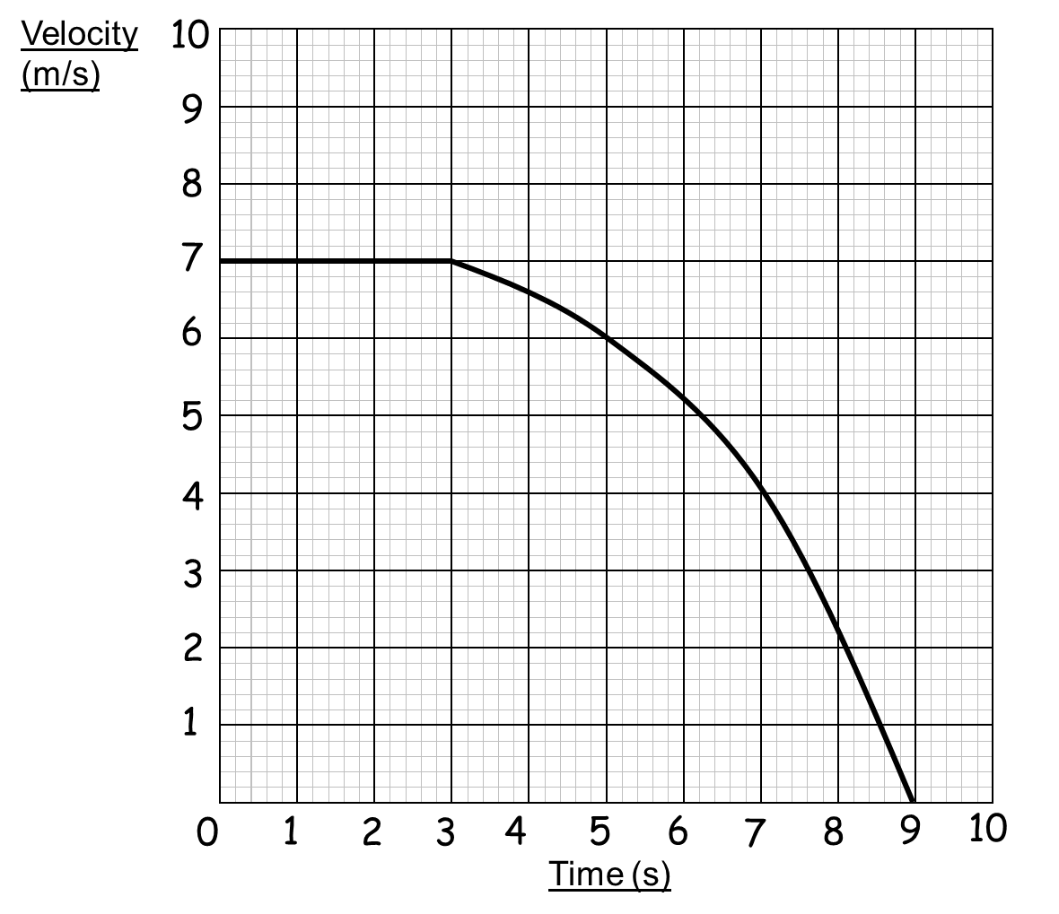

- 1 square = 1 m s⁻¹ x 1 s = 1 m
- Whole Squares = 44
- Segmented squares = 4
- 48 squares x 1 m = 48 m

Calculate the area under the following graphs.
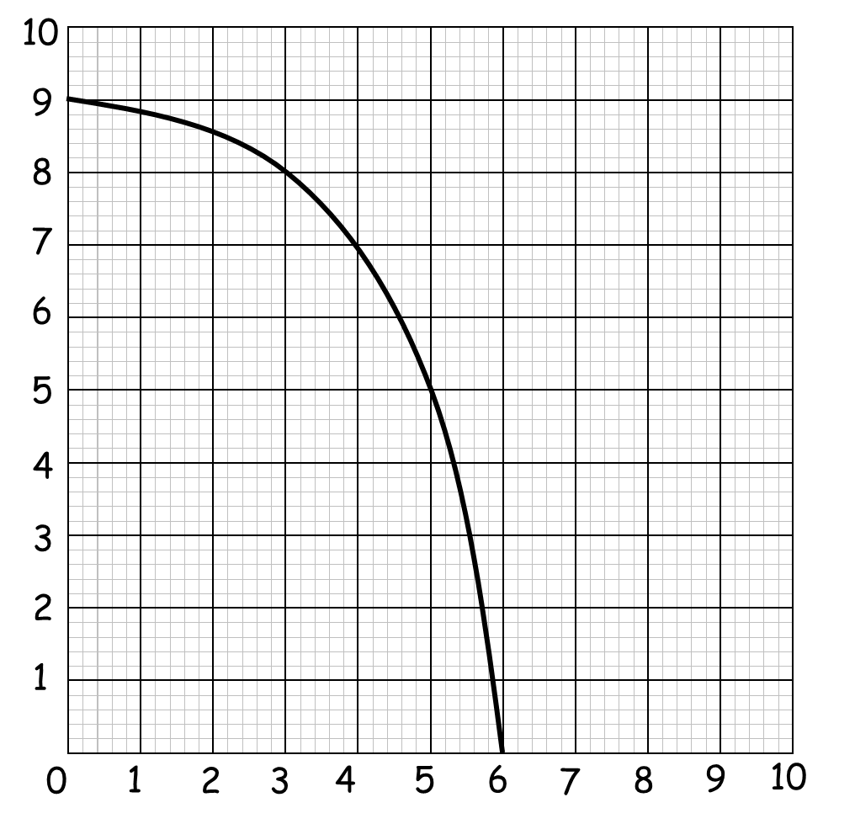
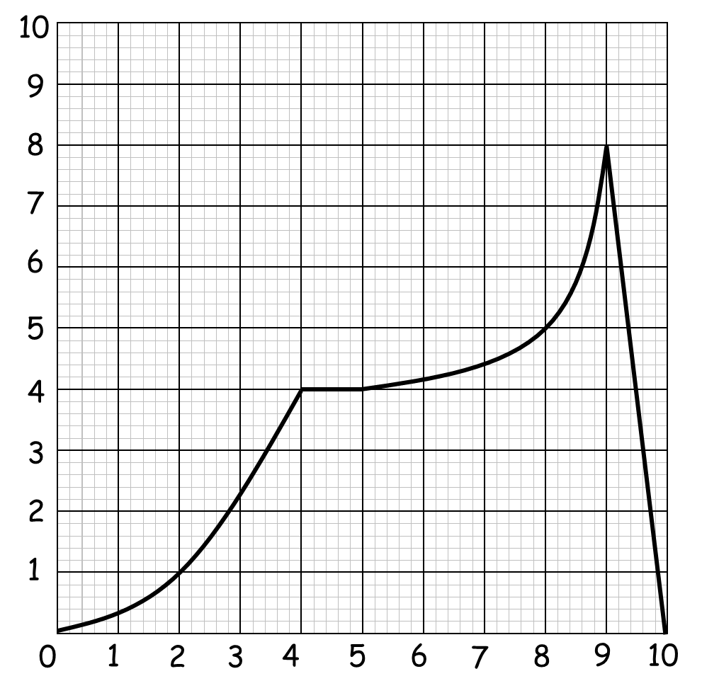
velocity/m s⁻¹ velocity/ km s⁻¹

time /s time /min

A Level Physics | 13. Interpreting Graphs
Skills

When interpreting graphs that are worth more than 2 marks, you need to go into more detail describing how the gradient changes over time and pick specific values to help support your answer.

Tips:
Use the quantities on the axes to support your answer.
Are there any points where the y value doesn’t change? What is this value? When does this happen on the x axis?
Are there any maximum or minimum values? What are they? When do they occur?
The gradient increases/decreases at a constant/increasing/decreasing rate….
Does the gradient represent anything (eg. velocity or acceleration)?
Are there multiple gradients? Are some steeper than others?

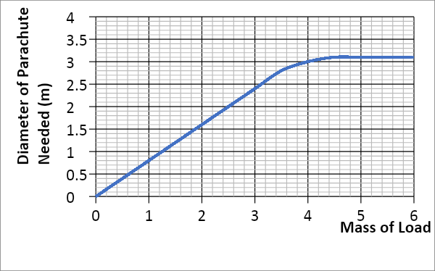

As the mass of the load increases, the diameter of the parachute needed also increases at a constant rate. This occurs to a mass of 3.4kg (which gives a diameter of 2.8m), where the gradient increases at a decreasing rate until the diameter remains constant at 3.1m for any load beyond 4.4kg. .
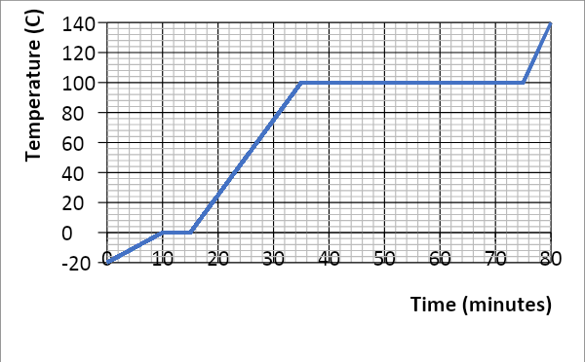
Describe in detail each graph. Write your answer at the side of each graph. Include the points mentioned under ‘tips’ in your answers.

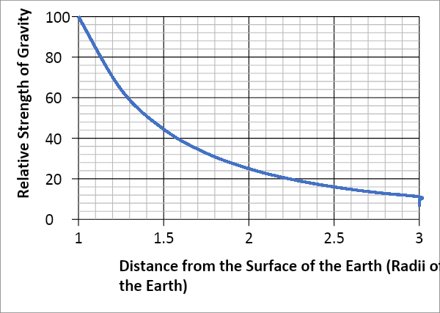

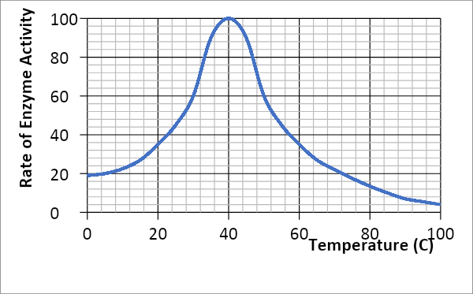

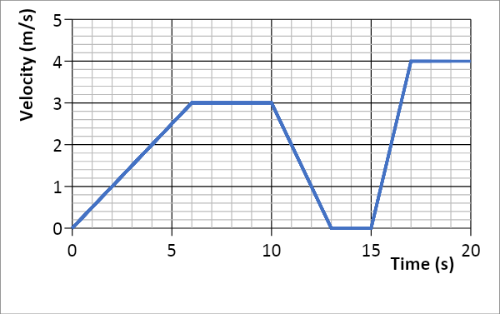

A Level Physics | 14. Accuracy, Precision, Resolution
Skills

An accurate result is one that is judged to be close to the true value. It is influenced by random and systematic errors.

The true value is the value that would be obtained in an ideal measurement.

A precise measurement is described when the values ‘cluster’ close together. We describe measurements as precise when repeated values are close together (consistent). It is influenced by random effects.

Resolution is the smallest change in the quantity being measured that causes a perceptible change in the output of the measuring device. This is usually the smallest measuring interval. It does not mean a value is accurate.

Uncertainty is variation in measured data and is due to random and systematic effects. We usually assume the uncertainty is the same as the resolution of the measuring instrument.
example ruler, resolution +/- 1 mm so uncertainty is also +/- 1 mm
Stop watch used by a pupil, resolution +/- 0.01 s but uncertainty estimated as +/- 0.2 s due to
human reaction time.
For our exam we estimate uncertainty and as long as you have a sensible justification your answer will be ok.

Eg. The true temperature of the room is 22.4 °C. One thermometer gives a reading of 22 °C and another gives a reading of 23.4 °C . Which is most accurate and estimate its uncertainty?

23.4 °C has the best resolution but is not close to the correct value.
22°C has less resolution but is more accurate as it is closer to the correct result.
The uncertainty in this reading is 22 +/− 1 °C

Example
Isabelle is finding the mass of an insect, but the insect moves while on the electronic balance.

She records a set of readings as 5.00 mg , 5.01 mg, 4.98 mg, 5.02 mg.
The true value of the insect’s mass is 4.5 mg.
Calculate an average value with estimated uncertainty for her results and compare this value with the true value using the terms above.

A Level Physics | 15. Identifying Errors
Skills

There are two main types of error in Science:
- Random error
- Systematic error

Random errors can be caused by changes in the environment that causes readings to alter slightly, measurements to be in between divisions on a scale or observations being perceived differently by other observers. These errors can vary in size and can give readings both smaller and larger than the true value.
The best way to reduce random error is to use as large values as possible (eg. Large distances) and repeat and average readings, as well as taking precaution when carrying out the experiment.

Systematic errors have occurred when all readings are shifted by the same amount away from the true value.
The two main types of systematic error are:
- Zero error – this is where the instrument does not read zero initially and therefore will always produce a shifted result (eg. A mass balance that reads 0.01g before an object is placed on it). Always check instruments are zeroed before using.
- Parallax error – this is where a measurement is not observed from eye level so the measurement is always read at an angle producing an incorrect reading. Always read from eye level to avoid parallax.
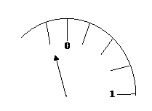
Zero Error
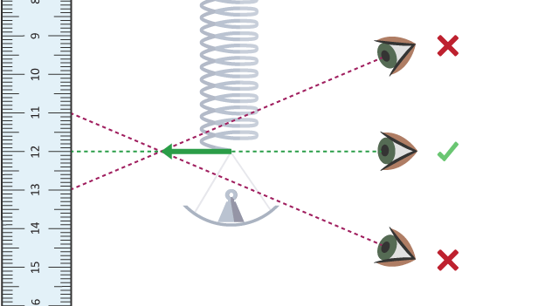

Parallax Error

Repeat and averaging experiments will not reduce systematic errors as correct experimental procedure is not being followed.

There are occasions where readings are just measured incorrectly or an odd result is far away from other readings – these results are called anomalies. Anomalies should be removed and repeated before used in any averaging.

For each of the measurements listed below identify the most likely source of error what type of error this is and one method of reducing it.

Measurement | Source of error | Type of error
A range of values are obtained for the length of a copper wire
The reading for the current through a wire is 0.74 A higher for one group in the class
A range of values are obtained for the rebound height of a ball dropped from the same start point onto the same surface.
A few groups obtain different graphs of resistance vs light intensity for an LDR. A light bulb placed at different distances from the LDR was used to vary the light intensity.
The time period (time of one oscillation) of a pendulum showing a range of values

A Level Physics | 16. Improving Experiments –  Accuracy, Resolution and Reliability
Skills

When improving accuracy, you must describe how to make sure your method obtains the best results possible. You should also try to use as large quantities as possible as this reduces the percentage error in your results. Also make your range as large as possible, with small intervals between each reading.
Resolution refers to the smallest scale division provided by your measuring instrument, or what is the smallest non-zero reading you can obtain from that instrument.
Reliability refers to how ‘trustworthy’ your results are. You can improve reliability by repeating and averaging your experiment, as well as removing anomalies.
Complete the table below to state how to use the measuring instruments as accurately as possible, as well as stating the precision (smallest scale division) of each instrument.

Measuring Instrument | Accuracy  What procedures should you use to ensure you gain accurate results? | Resolution  State the resolution of the instruments shown in the diagram.
Measuring Cylinder
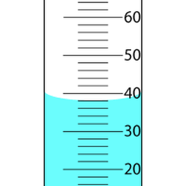
Top Pan Electronic (Mass) Balance
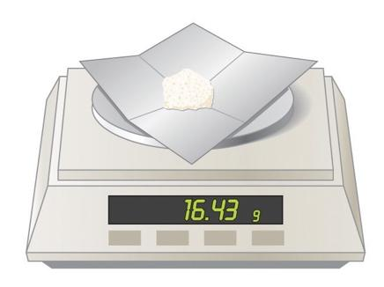
Measuring Instrument | Accuracy  What procedures should you use to ensure you gain accurate results? | Precision  State the precision of the instruments shown in the diagram.
Ruler

Thermometer

Research and describe a method to determine the thickness of one sheet of A4 paper accurately. You may only use a mm ruler. You should also refer to the precision and reliability of your result.

A Level Physics | 17. Describing Experiments
Skills

Variables – Which variables will you keep the same and which will you change?
Instruments – What measuring instruments will you use and how will you take the measurements?
Range – Give specific values for the range and intervals you will use. Make sure your range is large with small intervals.
Analyse – State any equations you will use and what graph you will plot including the axes.
Accuracy – State ways you are being accurate with your measuring instruments.
Reliability – State “Repeat and average” to improve reliability

Using the steps above, describe how to carry out the following experiments below:

e.g.
Water is placed in a plastic tray, one end it raised, dropped and the speed of the water wave is measured. A student suggests that the speed of the wave depends on the height of the water in the tray. How could you prove this?

Change the depth of water by filling the tray to different heights. The height of the water will be measured by placing a ruler into the tray. Depths from 1.0 to 5.0 cm, at 1.0 cm intervals should be used.
The tray should be lifted to the same height each time and dropped without pushing it down. The height the tray is lifted to should also be measured with a ruler that is vertical using a set square.
When the tray hits the table, the time should be measured for the wave to pass end to end 4 times, then divided by 4 to make the reading more accurate to reduce reaction time. The time should be measured using a stopwatch.
The length of the tray should be measured using a ruler, overhead and measured at eye level for accuracy.
The equation speed = distance / time should be used to calculate the speed of the wave.
Repeat each height and average to improve reliability.
Plot a graph of speed (y axis) vs depth of water (x axis) to see if there is a relationship between the two
variables.

Question. A student suggests that if an egg was dropped from different heights the area of splatter would increase as the height increases but only until a certain point. How could you investigate this?

A Level Physics | 18. Appendix 1- Solutions
Skills

Topic 1

54 x 10⁶ 0.086 x 10⁻⁶ 753 x 10⁹ 23.87 x 10⁻³

0.5 μm 93.09 Gm 3 200 kN 2.4 nm

s | ms | μs | ns | ps
0.00045 | 0.45 | 450 | 450 000  or 450 x10³ | 450 x 10⁶
0.000000789 | 0.000789 | 0.789 | 789 | 789 x 10³
0.000 000 000 64 | 0.000 000 64 | 0.000 64 | 0.64 | 640

mm | m | km | µm | Mm
1287360 | 1 287.360 | 1.28 7360 | 1 287 360 000 | 0. 001 287 360
295 | 0.295 | 0.000 295 | 295 000 | 0 .000 000 295

2. v = f λ = 0.25 x 10⁶ x 5.6 x 10⁻⁶ = 1400 m s⁻¹
3. λ = v/f = 330 / 3.0 x 10⁹ = 1.1 x 10⁻⁷ m

4. f = v/ λ = 300 x 10⁶ / 0.050 x 10⁻³ = 6.0 x 10¹² Hz = 6.0 THz

5. f = v/ λ = 300 x 10⁶ / 6.0 x 10⁻² = 5.0 x 10⁹ Hz = 5.0 GHz

Topic 2

Value | Sig Figs | Value | Sig Figs | Value | Sig Figs | Value | Sig Figs
2 | 1 | 1066 | 4 | 1800.45 | 7 | 0.070 | 2
2.0 | 2 | 82.42 | 4 | 2.483 x 10⁴ | 4 | 69324.8 | 6
500 | 1 | 750000 | 2 | 0.0006 | 1 | 0.0063 | 2
0.136 | 3 | 310 | 2 | 5906.4291 | 8 | 9.81 x 10⁴ | 3
0.0300 | 3 | 3.10 x 10⁴ | 3 | 200000 | 1 | 40000.00 | 7
54.1 | 3 | 3.1 x 10² | 2 | 12.711 | 5 | 0.0004 x 10⁴ | 1

Value 1 | Value 2 | Value 3 | Total Value | Total to correct sig figs
51.4 | 1.67 | 3.23 | 56.3 | 56.3
7146 | –32.54 | 12.8 | 7126.26 | 7126
20.8 | 18.72 | 0.851 | 40.371 | 40.4
1.4693 | 10.18 | –1.062 | 10.5873 | 10.59
9.07 | 0.56 | 3.14 | 12.77 | 12.77
739762 | 26017 | 2.058 | 765781.058 | 765781
8.15 | 0.002 | 106 | 114.152 | 114
152 | 0.8 | 0.55 | 153.35 | 153

Value 1 | Value 2 | Total Value | Total to correct sig figs
0.91 | 1.23 | 1.1193 | 1.1
8.764 | 7.63 | 66.86932 | 66.9
2.6 | 31.7 | 82.42 | 82
937 | 40.01 | 37489.37 | 37 500
0.722 | 634.23 | 457.91406 | 458

Value 1 | Value 2 | Total Value | Total to correct sig figs
5.3 | 748 | 7.085561 x 10⁻³ | 7.1 x 10⁻³
3781 | 6.50 | 581.6923077 | 582
91 x 10² | 180 | 50.55555555556 | 51
5.56 | 22 x 10⁻³ | 252.727272727 | 250
3.142 | 8.314 | 0.37791677 | 0.3779

Value 1 | Value 2 | Value 3 | Mean Value | Mean to correct sig figs
1 | 1 | 2 | 1.3333 | 1
435 | 299 | 437 | 436 | 436
5.00 | 6.0 | 29.50 | 5.50 | 5.5
5.038 | 4.925 | 4.900 | 4.9543333333 | 4.954
720.00 | 728.0 | 725 | 724.3333333333 | 724
0.00040 | 0.00039 | 0.000380 | 0.000380 | 0.00038
31 | 30.314 | 29.7 | 30.338 | 30

Topic 3
6 m² | = | 60 000 cm² |  | 750 mm² | = | 0.00075 m²
0.002 m² | = | 2000 mm² |  | 5 x 10⁻⁴ cm³ | = | 5.0 x10⁻¹⁰ m³
24 000 cm² | = | 2.4 m² |  | 8.3 x 10⁻⁶ m³ | = | 8300 mm³
46 000 000 mm³ | = | 0.046 m³ |  | 3.5 x 10² m² | = | 3.5 x 10⁶ cm²
0.56 m³ | = | 560 000 cm³ |  | 152000 mm² | = | 0.152 m²

31 x 10⁸ m² | = | 3100 km²
59 cm² | = | 5900 mm²
24 dm³ | = | 24000 cm³
4 500 mm² | = | 45 cm²
5 x 10⁻⁴ km³ | = | 500 000 m³

A 2.0 m long solid copper cylinder has a cross-sectional area of 3.0 x10² mm². What is its volume in cm³?
h= 2.0 m = 2.0 x 10² cm csa = 3.0 cm²
V = cross-section area x height = 2.0 x 10² x 3.0= 600

Volume = 600 cm³

5 N cm⁻² | = | 50 000 N m⁻²
1150 kg m⁻³ | = | (1150 x1000 / 100x100x100) = 1.15 g cm⁻³
3.0 m s⁻¹ | = | ( 3.0 /1000) x (60x60) = 10.8 km h⁻¹
65 kN cm⁻² | = | 650 N mm⁻²
7.86 g cm⁻³ | = | 7860 kg m⁻³

Topic 4
R = V/I t = Q/I A = ρL/A r = (ε-V)/I
u = 2s/t - v f=( Φ + E_{K})/h g= E_{P,}/ mh F= 2E/e
u= √( v²-2as) m = T² k/ 4π²

Topic 5
Case study 1
IV Mass of sphere DV time to fall a set distance CV drop distance, diameter of sphere
IV continuous graph - line graph
Case Study 2
IV types of activities DV number of children CV time of day and day of the week
IV categoric / discrete graph bar chart

Case study 3
IV Value of mass (g) DV length of spring CV same spring, spring stationary when measured
IV continuous graph line
Case study 4
IV number of blades DV output potential difference
CV same dist from fan, constant fan output, same blade design
IV discrete graph bar chart
Topic 6.
Pd across resistor/V | Current through the resistor/A
 | I₁ | I₂ | I₃ | I_{average}
1.0 | 0.11 | 0.10 | 0.12 | 0.11
2.0 | 0.21 | 0.18 | 0.24 | 0.21
3.0 | 0.33 | 0.60 | 0.30 | 0.32
4.0 | 0.35 | 0.40 | 0.45 | 0.40
5.0 | 0.50 | 5.10 | 0.48 | 0.49

Topic 7
- Straight line positive gradient , constant
- Curve, negative gradient, steep then getting shallower
- Straight line, negative gradient, constant
- Straight line positive gradient, constant
- Curve , positive gradient, decreasing
- Curve, positive gradient, increasing.

Topic 8
Use S L A P U ( 5 mark) criteria. Graphs will be reviewed in the new term.
Topic 9
Show construction lines on your graphs.
- m = 124-0/50-0 = 2.5 2. m = 22.5 -2.0/5.0-0 = 4.1
3. m= 112 - 42/11-4 = 10 4. m = 0.07-0.14/24-17 = -0.01

Topic 10.
Construction lInes need to be drawn on graphs for the full method.
- Gradient at point 2.0 m= 22-0/4-0 = 5.5 gradient at point 4.0 m= 46-0/5.0-1.8 = 14.4
- Gradient at point 1.5 m= 424-0/4-1 = 14.7 gradient at point 3.5 m= 116-0/4-2 = 58

Topic 11- always show a full method with your solutions.

Top graph area = 39 m Bottom graph area = 33 +/- 1 m ( to 2 sig fig)

Topic 12. All values approximate, your estimate should be within quoted error.
Left hand graph- 41 squares each square 1 m s⁻¹ x 1 s = 1 m area = 41 m +/- 1 m

Right hand graph 31 squares each square 1 km s⁻¹ x 60 s = 60 km area = 1860 km +/- 60 km

Topic 13.

Graph 1- 0-10 minutes temperature rises at a constant rate from -20 ⁰C to 0 ⁰C of 2 ⁰C min⁻¹.
Ice gaining thermal energy.
10-15 minutes temp is constant at 0 ⁰C as a change of state occurs; solid to liquid.
15- 35 minutes temp rises at 5 ⁰C min⁻¹, constant rate because gradient is constant.
35-75 minutes temp constant at 100 ⁰C, change of state ; liquid to gas.
75-80 minutes rapid increase in temp, gradient steepest 8 ⁰ min⁻¹, gas phase.
( values are expected from the graph as is suitable theory; you are expected to recognise graphs).

Graph 2.
As the distance increases from Earth the (relative) value of g decreases. Large decrease initially seen by steep gradient with gradient decreasing as distance increases.
Taking values from graph:
relative dist 1.0, relative g =100 relative dist 2.0, relative g =25, double d , g drops by 4
relative dist 1.5, relative g = 44 relative dist 3.0, relative g =11, double d, g drops by 4
We are always looking for patterns in data, gradients, areas or values such as above.

In this case doubling the distance drops g by a factor of 4; called the inverse square law.
This is a very important law in Physics

Graph 3.
Section 1 At 0 ⁰C activity low at 20 units ( no units given so we use units as a term) rising to a max activity of 100 units at 40 ⁰C.

Section 2 From peak at 40 ⁰C activity rapidly drops to a low of 4 units at 100 ⁰C.

Optimum activity is at 40 +/- 4 ⁰C

Graph 4. 6- sections ( only 2 described you need to write a description for all sections)

Section 1 - Constant acceleration of 3/6=0.5 m s⁻² for 6 seconds, covering a displacement from the start point of
(3 x 6)/2 = 9m
Section 2 - constant velocity of 3 m s⁻¹ for 4 seconds covering a displacement of 3 x 4 = 12m

Topic 14.

Average mass = 20.01/4 = 5.00 +/- 0.01g ( uncertainty is +/- the resolution of instrument)
Recorded values are precise as the repeat readings are close together but they are not accurate because the average value does not equal the true value. Do not confuse resolution with precise.
There is possibly a zero error on the balance as all the recorded values are above the true value by a similar amount.

Topic 15

Measurement | Source of error | Type of error
A range of values are obtained for the length of a copper wire | RULER measuring length of wire | RANDOM
Reduce this error by ensuring the wire is laid out straight, place the rules directly next to the wire, take repeat readings, remove anomalous readings and calculate an average length for the wire
The reading for the current through a wire is 0.74 A higher for one group in the class | Ammeter | SYSTEMATIC
Zero error in the ammeter. Check reading before any current flows in the circuit. Subtract zero error reading from each value or calibrate/adjust ammeter to read zero.

A range of values are obtained for the rebound height of a ball dropped from the same start point onto the same surface. | Ruler / person measuring rebound height | RANDOM  SYSTEMATIC
RANDOM because person recording the height looks at the rule from different positions and or doesn’t use same part of ball to record max height.
SYSTEMATIC because rule might have a zero error.
Solution- put graph paper scale on a screen behind the ball. Drop the ball close to the screen and record the fall in slo-mo using a camera ( smart phone). Analyse the play back to get accurate values.

A few groups obtain different graphs of resistance vs light intensity for an LDR. A light bulb placed at different distances from the LDR was used to vary the light intensity. | Additional light sources in the room | SYSTEMATIC
Some groups may be near a window which will allow extra light onto the measuring equipment beyond that from the light bulb used in the initial experiment. Reduce error by using proper black out curtains and switch off additional light sources while taking readings or cover the apparatus with blackout material.

The time period (time of one oscillation) of a pendulum showing a range of values | Timing the oscillation | Random
Time 20 oscillations and divide by 20. Use a fiducial mark ( pin as a point of reference) to help determine the point of one complete oscillation while counting the 20 oscillations. Release the pendulum at the same amplitude- should be a small angle of about 15⁰ from vertical.

Topic 16

Measuring cylinder - Read the volume of water from the bottom of the meniscus and perpendicular to the scale to reduce
parallax error. resolution/error +/- 2 ml

Top pan electronic balance - Ensure balance is zeroed before any reading are taken.
Make sure paper is not touch surfaces either side of the active top pan measuring surface.
Ensure no breeze or external forces are acting on the top pan.
resolution/error +/- 0.01g

Ruler - Place the ruler adjacent to the object being measured to reduce parallax error.
Make sure zero is placed at the start of the object being measured.
Ensure ruler is parallel to the measured surface.
resolution/error +/- 1 mm

Thermometer - Read the top of the active liquid and perpendicular to the scale to reduce parallax error.
resolution/error +/- 2⁰C (estimate, we should be better than +/- 5⁰C increments shown on the scale) .

Topic 17.

Some pointers.
Produce an equipment list; think of key/essential equipment .
IV height egg dropped from, m
DV diameter of splatter, m ( area, m² , calculated from this value, we don’t calculate the area directly)
CV size of egg, type of surface the egg is dropped onto.
Range of IV 0.50 to 4.00 m in 0.50 m increments.
Give a suitable table with heading /units
Graph plotted of height egg dropped (m) on x-axis v area of splatter ( m² )
Add more detail to your method and hand in with the rest of the notes.
Your method should be detailed enough to be followed and the experiment carried out.

A Level Physics | 18. Appendix 2- It’s all Greek
Skills

You are expected to know most of these letters.
The letters we will not use at A level are zeta, chi, psi, iota, kappa, xi, omicron.

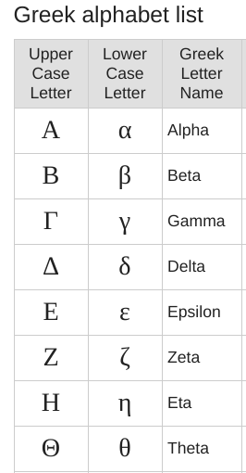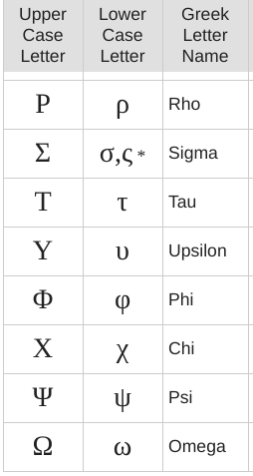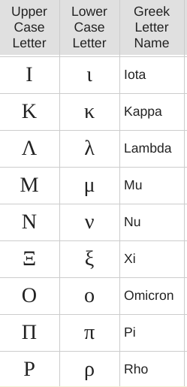

Note.

The second lower case symbol for sigma is used at the end of Greek words and not in our equations.

TASK. Write out the Greek letters that you have used in physics and mathematics.
Can you find other letter you have not used yet? If so write them out.
We often use the upper and lower case letters so learn both.

