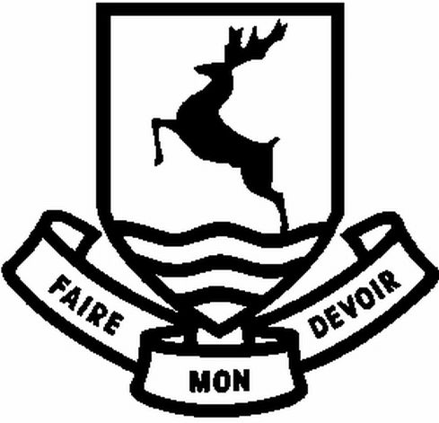

Design technology at verulam
Technology is a popular and successful subject at Verulam. We believe that all students have the potential to develop excellent design technology skills, incorporating creativity, higher order thinking and outstanding practical outcomes. Our vision is to provide student with exciting lessons through engaging and enjoyable lessons.
Our aim for all students is to:
- Create enthusiastic learners.
- Appreciate the benefits of design and technology in order to solve real life problems creatively.
- Recognise the value and importance of design and technology as a practical and theoretical subject.
- Apply problem solving skills.
- Become fully conversant with a range of media in order to communicate design solutions.
- Evaluate and reflect on their own learning, take responsibility and approach the subject with determination and perseverance.

STAFFING
Mr N Phillips - Head of Design & Technology
Steve Pegg - KS3 Coordinator for Design & Technology
Richard Hall - Senior Teacher
Lucy Nelson - Teacher of Food
Emma Dury - Food Instructor
Nic Bowyer - Technician
Jacqui Bidwell - Food Technology Technician

FACILITIES AND RESOURCES
The Faculty has seven specialist design and technology rooms, each of which is equipped with subject specific equipment. Facilities include two dedicated CAD suites, an industry standard large format laser cutter, 3 workshops including a machine room and two food and nutrition classrooms with cooking facilities. Lessons are supported by in-house produced booklets and design portfolios. Electronic textbooks and class sets of traditional exam accredited textbooks are available for use at KS4 & 5.

The Curriculum
Design and technology is taught across all key stages. At KS3 pupils complete 4 subject modules each year using a wide range of materials and processes. Our KS3 projects are iterative in nature to enable skills development and foster creativity and to prepare pupils for GCSE. The majority of students take the subject as a GCSE option (AQA Food Preparation and Nutrition or Design & Technology.) Results for GCSE 2020 were: 69% (9-5) for RM specialism, 100% (9-5) for Systems and Control, 48% (9-5) Graphics and 63% (9-5) for Food.
In the Sixth Form we offer AQA Product Design and currently have 27 students studying the subject to A Level. Results in 2020 at A Level were 85% A*-C and an ALPS score of 4. We continue to have a number of students choosing to study design related courses at University, ranging from technically orientated courses to more design related courses.
A number of extra-curricular and enhancement opportunities are available to students each year and we are particularly proud of the performance of our students in the Arkwright engineering scholarship scheme we run. Every year we enter students who are required to sit an aptitude exam, excel at interview in order to gain a nationally recognised scholarship to support their A level studies and foster their interest in engineering as a view study and career option.

Assessment and setting
Design and technology is taught in mixed ability classes. Pupils are regularly assessed with formative feedback to encourage and improve their learning. NEA progress is combined with exam performance to monitor progress for exam classes.

