20th August 2020

Dear Parents/Carers
As we approach results day, we would like to update you regarding arrangements for collecting results, and subsequent next steps guidance and advice. We hope that, despite the unusual circumstances surrounding this year’s exam results, there will be much to celebrate and that students’ hard work will be recognised.
As previously communicated, exam results days are scheduled for Thursday 20th August 2020

Our results day will operate as follows
Results will be available at 10:00 am in the sport hall. Please follow the rules below:
- Use the Jennings Road entrance
- Use hand sanitiser station at the entrance to the sports hall centre
- Follow the one-way system in and out of the sports hall
- Only one student and one parent/carer
- Bring your own pen to sign for your results
- There will be staff available in the Sixth Form block to give support and guidance, which will be in relation to some course changes, for a minority of students. Everyone who applied to Verulam sixth form has a place in Verulam Sixth Form based on their Centre Assessed Results, which are now their final results.

The appeals process is still yet to be published but this will only focus on administrative issues and discrimination/bias. Attached is the Verulam Centre Assessed Grades/ Full strategy for your reference. BTEC results are still in the process of being reviewed by the Government

There is now no route to appeal in relation to Mock exam results, which was in the news last week. There remains the opportunity to do the examinations in the Autumn term. We are still waiting for full details regarding this from the Government.

We are looking forward to meeting you on results day to celebrate your success.

Yours sincerely
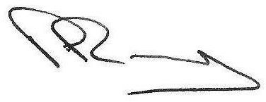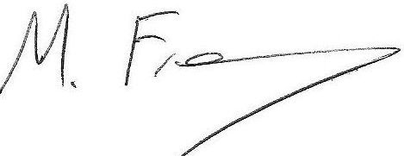

Mr P Ramsey Mr M. Freakley
Headteacher Deputy Headteacher

