In order to keep students, staff and families safe we need to follow these rules:

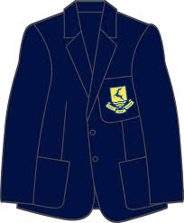

Wear full school uniform except days you have PE/Games | Bring exercise books and a pencil case in your school bag | Bring your own  water bottle
 |  | 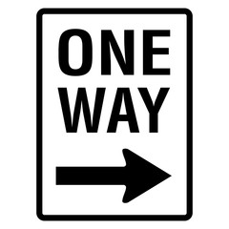
Arrive on time  (Not early or late) | Enter school via your allocated entrance | Follow the one-way system and staff instructions at all times
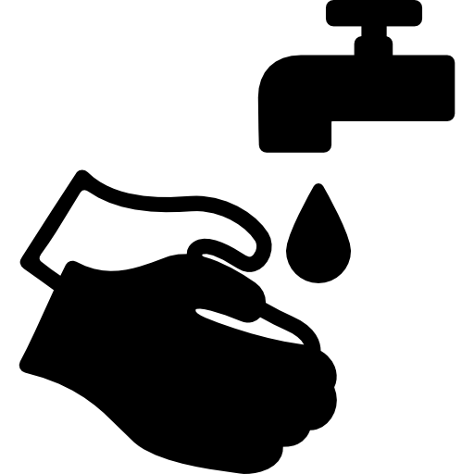
Wash or sanitise hands upon entry to school and throughout the day | Keep your distance at all times. 2m from staff | Line up in your year playground before school, end of break and lunch
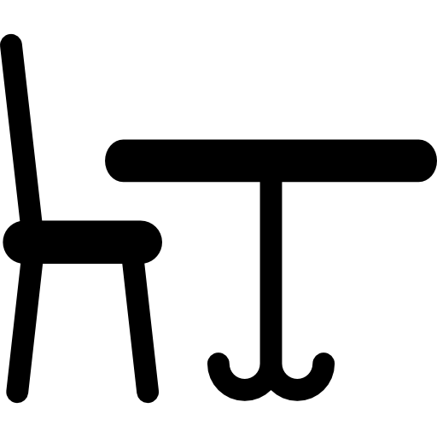 |  | 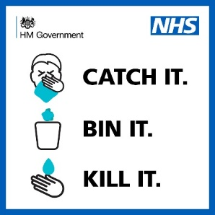
Keep to the seating plan and keep belongings under your desk | Maintain Social Distancing during break times

