Arithmetic – do in your head:
6.12 + 0.7 = | ^{5/}₆ – ^{1/}₆ = |  | ^{3/}₁₀ + ^{4/}₁₀ = | 20.3 – 18.2 =
^{1/}₃ x ^{1/}₅ = | 9 x 2 ¼ = |  | ^{2/}₃ ÷ 3 = | ^{1/}₃ + ¼ =
Reasoning questions – show your working:
In the chart any three  numbers in a line, across or  down, have a total of  18.45. Write the missing  number.  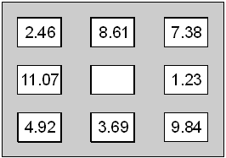 |  | Put a tick () in each row to  complete this table. One has  been done for you.  greater than less than  0.9  0.06  0.21
Circle the two fractions that  are equivalent to 0.6: |  | Circle two numbers which have a difference of 2:  –1 –0.5 0  0.5 1 1.5
Write the missing number on this number line:

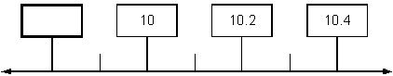

Arithmetic – do in your head:
8.6 – 3.75 = | ^{5/}₆ – ^{1/}₃ = | ^{3/}₁₀ + ^{4/}₁₅ = | 21.3 – 17.25 =
^{1/}₃ x ^{1/}₅ x ½ = | 7 x 22 ^{1/}₃ = | ^{1/}₅ ÷ 3 = | ^{1/}₃ + ^{1/}₆ + ^{1/}₉ =
Reasoning questions – show your working:
Write in the missing  numbers.  ÷ 21.7= 37.5  100 - (22.75 + 19.08) = |  | Calculate of 0.4 x 378.
 |  | Calculate 31.6 × 7.
7.4 8.1 9.4 10  Which two of these  numbers, when multiplied  together, have the answer  closest to 70?  and  Explain how you know.  …………………………………………  …………………………………………  …………………………………………  …………………………………………  …………………………………………  …………………………………………  …………………………………………  ………………………………………… |  | Here are five number cards.  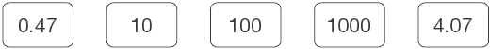  Use four of the cards (once each only) to complete these calculations.  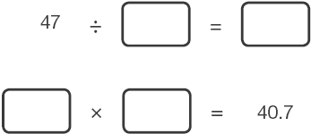
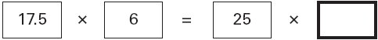
Write the missing number:
Arithmetic – do in your head:
28.16 – 23.75 = | ^{5/}₆ – (^{1/}₃ ₊ ¹_{/3}) = | ^{3/}₁₀ + ^{4/}₁₅ – ¹_{/5} = | 21.33 – 17.251 =
^{1/}₃ x ^{1/}₆ x ¹_{/9} = | 1½ x 22 ^{1/}₃ = | ^{6/}₂₁ ÷ 3 = | ^{1/}₃ + ^{1/}₇ + ^{1/}₈ =
Reasoning questions – show your working:
Write three decimals,  each greater than zero,  which add together to  make a total of 0.01.  +  + = 0.01 |  | Write two decimals, each less than  1, which multiply to make 0.1  × = 0.1
Write a decimal which is  greater than and less than . |  | Write a fraction which is greater  than 0.7 and less than 0.71.
.y stands for a number.  y × y × y = 5  The most accurate value for y to one decimal place is 1.7 because  1.7 × 1.7 × 1.7 = 4.913  k stands for a number.  k × k × k = 10  Find the most accurate value for k correct to one decimal place. |  | Working out for k question:

