**Mild: Calculate the Perimeter and Area of the following shapes**

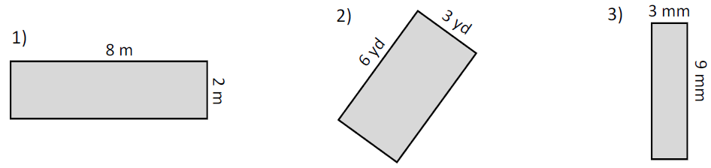

Perimeter = _____________ Perimeter = _____________ Perimeter = _____________

Area = ______________ Area = ______________ Area = ______________

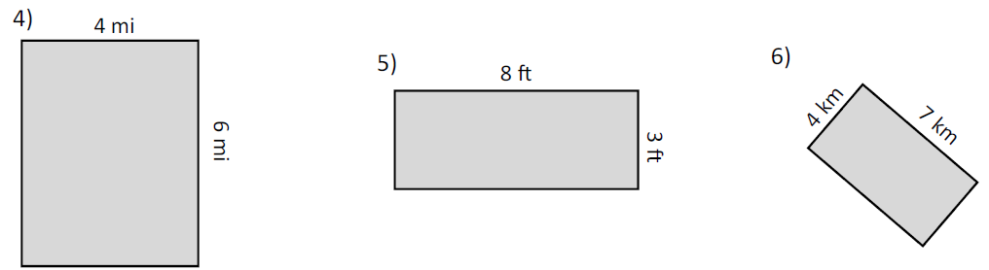

Perimeter = _____________ Perimeter = _____________ Perimeter = _____________

Area = ______________ Area = ______________ Area = ______________

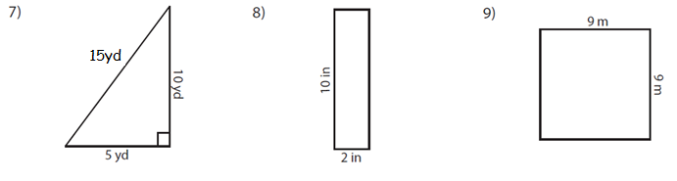

Perimeter = _____________ Perimeter = _____________ Perimeter = _____________

Area = ______________ Area = ______________ Area = ______________

**Spicy: Apply area and perimeter to functional questions**

|  |  |
| --- | --- |
| 1. A rectangular bedroom needs a new carpet. The cost of the carpet is £5 per m2. How much will the carpet cost? | 2. A rectangular bedroom (6m by 6m) needs a new carpet. The cost of the carpet is £5 per m2. How much will the carpet cost? |
| 3. A rectangular bedroom (5m by **120cm**) needs a new carpet. The cost of the carpet is £2 per m2. How much will the carpet cost? | 4. A rectangular room as the dimensions below. Carpet costs £5 per square metre. How much will it cost to carpet the full floor? |
| 4. A rectangular bathroom needs tiling. One pack of tiles covers 5m2. How many packs of tiles do I need? | 5. A square bathroom with side length 8m needs tiling. One pack of tiles covers 10m2. How many packs do I need? |
| 7. A rectangular room has the dimensions below. A wallpaper border costs £1 per metre. How much will it cost to put the border around the room? | 8. A rectangular garden (5m by **300cm**) needs fencing around the perimeter. It costs £2 per m. How much will it cost? |
| 9. A garden (10m by 4m) needs decorative fence around the perimeter. Fencing costs £1 per metre. How much will it cost me? | 10. Jo needs to put wallpaper border around the room shown below. Skirting costs £4 per m. How much will it cost? |

**HOT: Apply area and perimeter to functional questions in L-shapes**

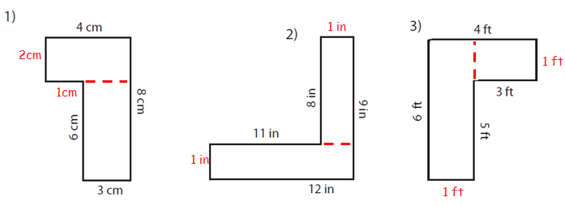

Perimeter = _____________ Perimeter = _____________ Perimeter = _____________

Area = ______________ Area = ______________ Area = ______________

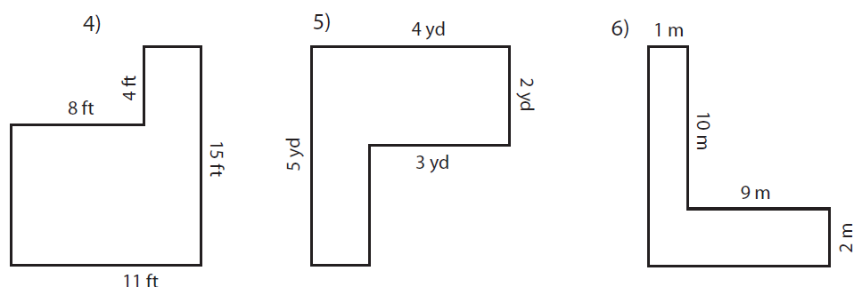

Perimeter = _____________ Perimeter = _____________ Perimeter = _____________

Area = ______________ Area = ______________ Area = ______________

|  |  |
| --- | --- |
| 7. This bedroom needs a new carpet. The carpet costs £8 per m2. How much would it cost to buy the new carpet? | 8. This bedroom needs a new carpet. One roll of carpet covers 10m2 and cost £20. How much would it cost in total? |

**Answers**

**Page 1 - 1) 20m, 16m2, 2) 18yd, 18yd2, 3) 27mm, 24mm2, 4) 20mi, 24mi2, 5) 22ft, 24ft2,**

**6) 22km, 28km2, 7) 30yd, 25yd2, 8) 24in, 20in2, 9) 36m, 81m2**

**Page 2 – 1) £120, 2) £180, 3) £12, 4) £1250, 5) 5 packs, 6) 7 packs, 7) £70, 8) £32,**

**9) £28, 10) £80**

**Page 3 - 1) 26cm, 24cm2, 2) 20in, 42in2, 3) 9ft, 20ft2, 4) 133ft, 52ft2, 5) 11yd, 18yd2,**

**6) 30m, 44m2, 7) £800, 8) £180**