Arithmetic – use jottings:
49 ÷ 70 = | ½ + 1/3 = | ¼ x 1/8 = | 0.1 ÷ 5 =
125 ÷ 5 = | 21 x 9 = | 8.1 ÷ 9 = | 123 + 39 =
Reasoning questions – show your working:
and each stand for a different number.
= 34
+ = + +
What is the value of ?

What is the value of 4x + 7 when x = 5?

Arithmetic – use jottings:
1/3 + 5/8 = | ¼ x 3/9 = | 1032 – 289 = | 68 x 92 =
0.25 ÷ 5 = | 1.4 ÷ 70 = | 82 ÷ 9 = | 182 ÷ 8 =
Reasoning questions – show your working:
Ann makes a pattern of L  shapes with sticks.  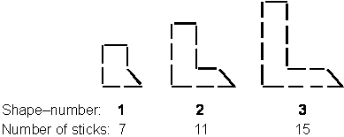  Ann says: “I find the number of sticks for a shape by first multiplying the shape-number by 4, then adding 3”.  - Work out the number of sticks for the shape that has shape-number 10.  - Ann uses 59 sticks to  make another L shape in  this pattern. What is its  shape-number? |  | Here are some picture frame sizes.  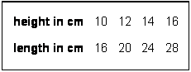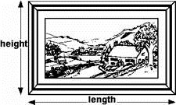  - For each frame, the length is  twice the height, subtract 4. What is the length of a frame which has a height of 36cm?  - For each frame, the length (L)  is twice the height (H), subtract 4.  Write this in symbols.

Arithmetic – use jottings:
1/8 x 3/7 = | 86 ÷ 5 = | 9.1 ÷ 9 = | 1/5 + 2/3 =
123 ÷ 7 = | 102 – 89 = | 3246 ÷ 23 = | 0.108 + 1.065 =
Reasoning questions – show your working:
In this equation N stands for  a number.  5N – 2 = 3N + 12  What is the value of N? |  | p + q = 1000  p is 150 greater than q.  Calculate the numbers p and q.
Javed makes rectangular  frames with grey centimeter  squares.  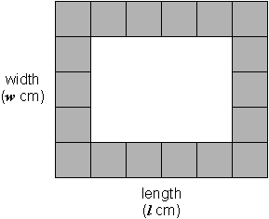  n stands for the number of  grey centimetre squares in  a frame. Javed has a  formula for working out n.  n = 2 (l + w) – 4  Javed makes a frame with l = 28 and w = 15.  Use the formula to work  out how many grey  squares he uses. |  | n stands for number.  Match the equivalent expressions.  One has been done for you.  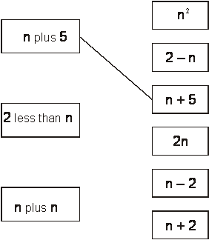
The sum of two numbers is 5.

The difference between the numbers
is 0.5.

What are the numbers?
A, B and C stand for three
different numbers.
The mean of A and B is 40.
The mean of B and C is 35.
A + B + C = 100
Calculate the values of A, B and
C.

