17th March 2020

Dear Parent/Carer

COVID-19 Update

Following the Government’s announcement yesterday afternoon, I have decided to make the following changes to school life from today.

- All trips for the remainder of this term and during the Easter holidays are cancelled. Where payments have been made, we will be in contact. It is likely that the suspension of trips will continue for some considerable time.
- Duke of Edinburgh Award expeditions are also cancelled for the rest of this term and during the Easter holidays.
- I regret that meetings with parents will now be conducted by telephone only and will not take place on site.

I would ask that parents familiarise themselves with the latest guidance from Public Health England which can be found here:

https://www.gov.uk/government/collections/coronavirus-covid-19-list-of-guidance

I will be sending home work for pupils who are self-isolating later today.

I will continue to update parents as soon as further information becomes available. Meanwhile, teaching and learning continues as normal.

Yours faithfully
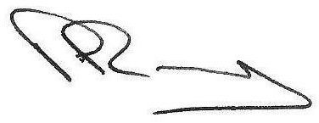

Mr P A Ramsey
Headteacher

