VERULAM SCHOOL

Model Payment of Governors’ Allowance Policy

Reviewed by  Resources Committee  MANAGING STAFF | 21/03/2019
Review Period | Annually
Date of Next Review | March 2020
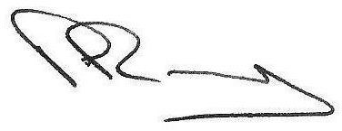  P A Ramsey  Headmaster | John Acton  Chair of Governors

Status
Statutory

Purpose

We believe that the governing body plays a key role in the success of the school. Individual governors should not be deterred from playing their full part because of incidental costs.

The Education (Governors Allowances) Regulations 1999 allow maintained schools to extend their schemes for paying governors’ expenses from the school’s budget. At the full governing body meeting held on 28th September 2010 it was agreed that the following expenses could be claimed from October 2010.

- Childcare or babysitting (other than done by a resident and responsible person at the home address) at a rate of £10 per hour.

- Care arrangements for a dependent (as above) at a rate of £10 per hour.

- Support for governors with special education needs (eg audio equipment), to be pre-agreed with Chair of Governors and School Business Manager.

- Support for governors whose first language is not English (eg translations), to be pre-agreed with the Chair of Governors and School Business Manager.

All claims should be submitted to the Chair of Governors who will forward to the School Business Manager to be signed off.

Relationship to other policies

This is referenced to the school’s equality policy.

Arrangement for monitoring and evaluation

The Resources committee will monitor and evaluate the impact of the policy annually with reference to the attendance records of governors at meetings and to the total sum paid out.

Date established by governing body 28th September 2010

Date for full implementation October 2010

Next Review March 2020

